PART III

An Experiment to Prove the Existence
of the Behavior of Inertia

Materials needed:

- A weighted block of wood
- A smooth table whose coefficient of friction had been experimentally established with respect to the block
- Set of weights
- Ring-head screws
- A nail whose diameter is smaller than the inside diameter of the ring-head screw
- Hook and pulley
- Nylon string

Procedure and Observations:

1. Drive the ring-head screws at the center of the cross-sectional ends of the block.
2.Place the block on top of the table and drive the nail through one of the rings in such a way that the block would be able to freely rotate around the nail.
3.Set the pulley, the string and hook at the edge of the table as shown below and represent the weights to be applied as P and the nail, to represent the moment axis:

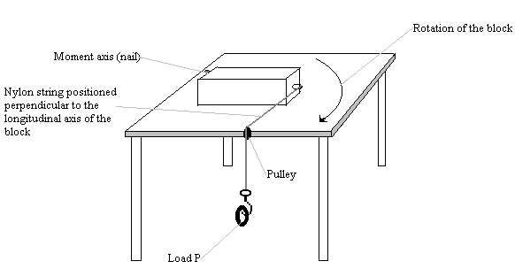

4. Compute the required load P that would put the block in a state of impending motion around the moment axis (nail). Employing existing and accepted method in solving for P:
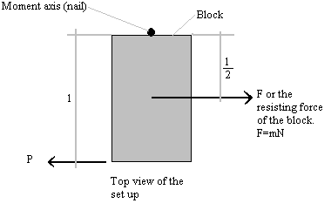

Let N be the weight of the block
Let m be the coefficient of friction between the block and the table
Summation of Moments equal to zero, clockwise positive
Therefore:
$$\begin{aligned}0=\text{Pl}−\text{mN}\left(\frac{l}{2}\right) \\ P=\frac{\text{mN}}{2}\end{aligned}$$

5. Apply the computed P, or weights, to the set up and observe the reaction of the block. You will notice that the computed P does not put the block into a state of impending rotational motion but accelerates the block into motion in a rotational manner.
6. Considering now the Behavior of Inertia, compute the P required to put the block into a state of impending rotational motion:

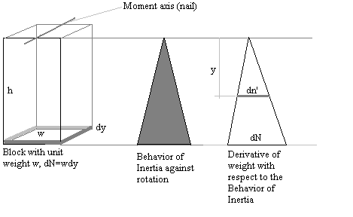
$$\begin{aligned}\frac{\text{dN}}{h}=\frac{\text{dn}'}{y} \\ \text{dn}'=y\frac{\text{dN}}{h} \\ \text{dN}=\text{wdy} \\ \text{dn}'=\frac{\text{wy}}{h}\text{dy} \\ n'=\frac{w}{h}\int_{o}^{h}{\text{ydy}} \\ n'=\frac{\text{wh}}{2}=\frac{N}{2}\end{aligned}$$
Therefore, considering the Behavior of Inertia, the resisting force of the block on the surface of the table against rotational motion is $F=m\frac{N}{2}$ concentrated at two-thirds of the length of the block from the moment axis. Taking the summation of moments:

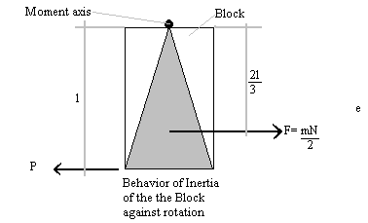

$$\begin{aligned}\text{Pl}=\frac{\text{mN}}{2}\left(\frac{2l}{3}\right) \\ P=\frac{\text{mN}}{3}\end{aligned}$$

7. Apply the new load P at the set up and observe the reaction of the block. You will see that the new P puts the block in a state of impending rotational motion around the moment axis (nail). To prove this state of impending rotational motion of the block, add a slight load to P and you will witness how the block breaks away from its state of impending rotational motion.

