PART IV
Immediate Implications of the PMM

The process of geometrically creating the image of the Moment of Inertia alone is a huge contribution to the field of Science and Engineering. Before, the Moment of Inertia was very abstract without a form from which its value can be concretely taken. In my opinion, the PMM should be the fundamental tool in evaluating the Moment of Inertia especially in designs of structures, other existing methods, for checking. In addition, the consideration of the Behavior of Inertia in the evaluation of the Moment of Inertia unraveled before us the many facets of the Moments of Inertia of a body with respect to a moment axis like; the moment axis as the axis of rotation, the perpendicular passing of the body through the moment axis, the moment axis not the axis of rotation, and probably, many more combinations of conditions.

On the other hand, the Behavior of Inertia identifies for Scientist and Engineers the actual reacting inertia of a body against an external rotational force and also gives them the privilege of choosing or creating different shapes that would react with maximum inertia for required conditions. And since the Behavior of Inertia is a very fundamental phenomenon, its implications can be wide and far reaching. Aside from the obvious rectification that would be done to a basic principle in Physics and changes to formulas in structural and mechanical design related to it, the Behavior of Inertia might touch even the inertial relationships of stars, planets and galaxies, or, go and reinvestigate the relationships in the atomic world of protons and electrons.

My study of the Behavior of Inertia, if you would observe, is limited with matter in the state of rest. And since inertia is not always in the state of rest, the study of the Behavior of Inertia of matter in the state motion remains to be greatly untouched. There might be new concepts that could arise in the field of dynamic Behavior of Inertia. At the moment, only my imagination has ventured into this unchartered field.

As a holder of a degree in civil engineering, the field of study that introduced me to the Moment of Inertia, and that made me question and investigate the Moment of Inertia, and which led me to the study of the Behavior of Inertia, I am compelled to give an example of the PMM’s immediate implication to civil engineering.

An Example of the PMM’s Immediate Implication to Civil Engineering

Given: A beam with a rectangular cross section under bending stress. Find the Area Moment of Inertia of the beam at the neutral axis.

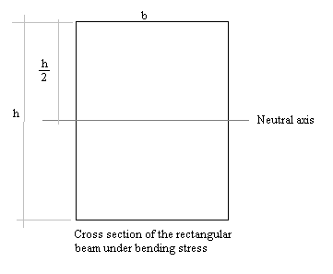

Normally, by Integral Calculus, the Moment of Inertia for this cross section is
$$I=\frac{{\text{bh}}^{3}}{\text{12}}$$
Let us investigate the stresses the rectangular strip of the beam is undergoing under bending moments.

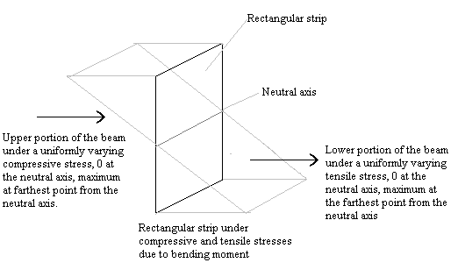

By the law of action and reaction itself, since the upper and lower portions of the beam are respectively under uniformly varying compressive and tensile stresses, then the inertia of the area of the rectangular strip of the beam should be taken as responding in the same manner. Considering the Behavior of Inertia, the rectangular cross section is expected to react with a uniformly varying inertia, theoretically 0 at the neutral axis to maximum at the farthest point from the neutral axis. To illustrate their similarity:

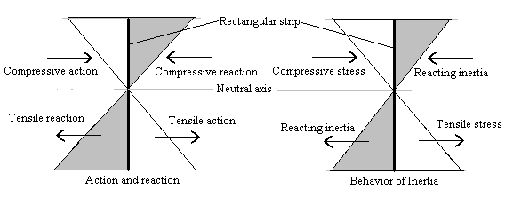

For both illustrations, the Area Moment of Inertia at the neutral axis, by the PMM is:
$$I=\frac{{\text{bh}}^{3}}{\text{16}}$$
On the other hand, the current accepted value $I=\frac{{\text{bh}}^{3}}{\text{12}}$ for the Area Moment of Inertia for the rectangular strip, at the neutral axis, by Integral Calculus, assumes that unit areas respond to compressive and tensile stresses in a uniformly distributed manner as shown below:

Za 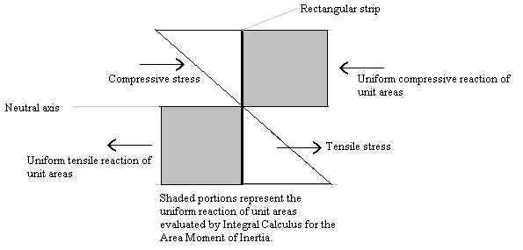

This mistake occurred, not because Integral Calculus was wrong but because Integral Calculus, as a Mathematical tool, depended upon the evaluator, man, who most probably just negligently depended on the tool to give a correct answer without first indentifying for the tool, Integral Calculus, the parameters of Inertia to be evaluated. Integral Calculus is a powerful Mathematical tool but it is still, and I believe will forever be, dependent on man to be able to give the correct answers. Man still needs to identify the parameters for Mathematical tools to evaluate equations properly and should not be contended with formulating equations and irresponsibly leave them to Mathematical tools to finish.

Thus, evaluating the rectangular strip by Integral Calculus alone, the reacting inertia would be overvalued by one hundred percent (100%):

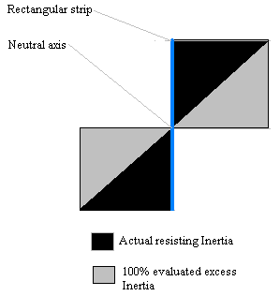
that would result into a greater Moment of Inertia,$I=\frac{{\text{bh}}^{3}}{\text{12}}$, than the actual Moment of Inertia of $I=\frac{{\text{bh}}^{3}}{\text{16}}$, a difference of $I=\frac{{\text{bh}}^{3}}{\text{48}}$, or an overevaluation of the Moment of Inertia of the rectangular strip at the neutral axis by twenty-five percent (25%).

