PART II
The Behavior of Inertia: A Brief Description

I discovered the Behavior of Inertia while I was evaluating and creating the image of the Moment of Inertia for volumes. What I found out about the behavior of inertia in volumes I believe also is true with mass and area. Actually with respect to mass, an experiment I have done proved that the phenomenon is true (with this paper is a proposed experiment to prove the existence of the Behavior of Inertia for the evaluator to perform). I still have to type into the computer the more detailed history of my findings but the description below is enough to capture its essence. However, it is essential that the evaluator, to understand and appreciate the behavior of inertia needs to accept and have a full knowledge of the process in geometrically creating the image of the Moment of Inertia.

Before, we believed that every rotating body resisted with an inertia equivalent to its entire mass,weight, area and volume. This is not so. I found out that the body reacts with a uniformly varying inertia against any external rotational force. This has been overlooked for a long time and probable anomalies that arose with respect to it were definitely relegated to some other reasons.

Let us evaluate a cube for the Moment of Inertia considering the Behavior of Inertia to rotate at a moment axis as shown:

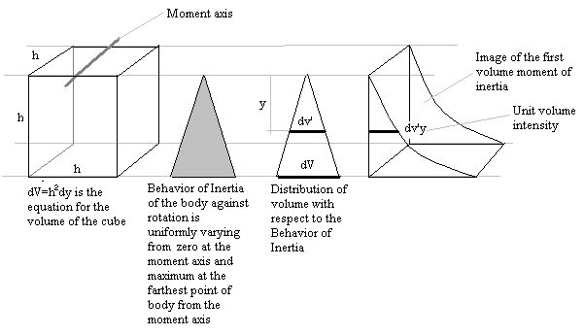

Let dV represent the derivative of volume of the cube.
Let dv’ represent the derivative of the of the volume of the cube with
respect to the Behavior of Inertia.
Let dv’y represent the product of the derivative of the volume of the cube with respect to the Behavior of Inertia and distance (y) from the moment axis, dv’ x y.
Let 3h/4 be the distance of the centroid of image to the moment axis.
Let $\text{dI}=\sum{\text{dv}'y\left(\frac{3h}{4}\right)}$ be the equation to determine the Moment of Inertia of the cube with respect to the Moment axis.

Therefore:

$$\begin{aligned}\frac{\text{dV}}{h}=\frac{\text{dv}'}{y} \\ \text{dv}'=\frac{y}{h}\text{dV} \\ \text{dV}=h^{2}\text{dy} \\ \text{dv}'=\text{hydy} \\ \text{dI}=\sum{}\text{dv}'y\left(\frac{3h}{4}\right)={\text{hy}}^{2}\text{dy}\left(\frac{3h}{4}\right) \\ I=h\int_{0}^{h}{y^{2}\text{dy}}\left(\frac{3h}{4}\right) \\ I=\frac{h^{4}}{3}\left(\frac{3h}{4}\right) \\ I=\frac{h^{5}}{4}\end{aligned}$$

Total volume (V) of the cube is h³, therefore:

$I=\frac{{\text{Vh}}^{2}}{4}$

Without considering the Behavior of Inertia, the Moment of Inertia of the cube with respect to the moment axis is $I=\frac{{\text{Vh}}^{2}}{3}$ because the total volume of the cube was considered to give a full inertia. But that is not so and you will find that this theoretical difference of $\frac{{\text{Vh}}^{2}}{\text{12}}$ as true when the experiment to prove the Behavior of Inertia is performed.

If the actual rotational Moment of Inertia of the cube is that which the Behavior of Inertia was considered, then the currently accepted rotational Moment of Inertia of the cube is twenty five percent (25%) greater than what is true.

However, if the rotational Moment of Inertia of the cube is not desired, that is, if the external force to be resisted by the cube is not rotational but axial that will make the cube perpendicularly pass the moment axis and not rotate around it, then the value that can acquired through the geometric image of the Moment of Inertia of the cube would be:

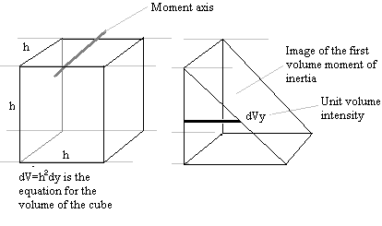

Let the new centroid be 2h/3.
Let $\text{dI}=\sum{\text{dVy}\left(\frac{2h}{3}\right)}$ be the equation of the Moment of Inertia of the cube perpendicularly passing the moment axis, therefore:

$$\begin{aligned}\text{dI}=\sum{\text{dVy}\left(\frac{2h}{3}\right)=h^{2}\text{dy}\left(y\right)\left(\frac{2h}{3}\right)} \\ \text{dI}=h^{2}\text{ydy}\left(\frac{2h}{3}\right) \\ I=h^{2}\int_{0}^{h}{\text{ydy}\left(\frac{2h}{3}\right)} \\ I=\frac{h^{5}}{3}=\frac{{\text{Vh}}^{2}}{3}\end{aligned}$$

It seems that the accepted value for the Moment of Inertia of the cube today, at an axis on top of the cube,$I=\frac{{\text{Vh}}^{2}}{3}$, is that of a cube perpendicularly passing the moment axis and not that of cube rotating the moment axis. This has happened for so long, not only to the cube but for every imaginable bodies, because, although Integral Calculus is a wonderful tool in the evaluation of the Moment of Inertia, it has been used improperly due to the absence of the knowledge about the Behavior of Inertia.

To further illustrate the superficiality of man’s present knowledge about Inertia, is it not possible that a cube we have just evaluated, in another condition, can have the same moment axis but a different axis of rotation? To illustrate:

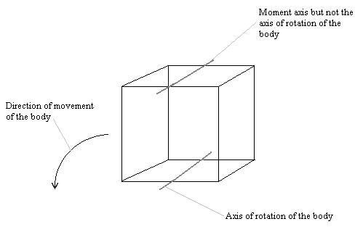

Under this new condition, the cube would definitely have a new value of Moment of Inertia with respect to the moment axis and with respect to the new axis of rotation. The solution for this new condition of the cube, I leave that to the reader or evaluator to do as an exercise.

