THE PARTICLE MOMENT METHOD

BY: NOEL C.ACHAS

Introduction

The Particle Moment Method (PMM) is a new way of determining the value of the Moment of Inertia by geometrically creating its image from which its value can be taken. The image of the Moment of Inertia unprecedentedly defines the parameters of the Moment of Inertia which now makes its evaluation more concrete and probably, precise.

Generally, to find the Moment of Inertia of an object, we were given the moment axis, the lever arm and the body to be evaluated. If the body is an amount of mass, we square the length of the lever arm (r²) and multiply it with the amount of mass (m) and we have the Mass Moment of Inertia:

I = mr²

In most cases, Integral Calculus is used as a Mathematical tool for the evaluation of the Moment of Inertia.

Let us evaluate a rectangular strip for the Area Moment of Inertia shown in Figure 1 using Integral Calculus.
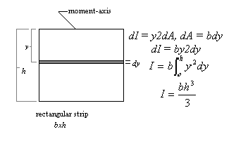
Figure 1

The mass, the moment-axis, the lever arm, the y² and dA are the components of the Moment of Inertia. These components generate the mass moment of inertia, the area moment of inertia and the volume moment of inertia. This relationship can be compared to that of a tank of liquid petroleum gas (LPG) and a stove that create a flame but are not the flame. The components of the moment of inertia create the moment of inertia but they are not the moment of inertia itself. Likewise, these components, along with Integral Calculus, have fortunately given us the value of the Moment of Inertia correctly for some condition, but not in every condition, as you will find out as we go along in our study. Our failure to see the image of the Moment of Inertia has led us to a wrong perception that the Moment of Inertia is simply always the product of the body and its squared distance from the moment axis.

By the PMM, we will learn that the value of the Moment of Inertia comes actually from the magnitude of the image that is formed by the particles of the body with respect to the moment-axis. We will also discover that existing Integral Calculus equations,

dI = y²dM (for Mass Moment of Inertia),
dI = y²dA (for Area Moment of Inertia), and
dI = y²dV (for Volume Moment of Inertia)

are limited in their capacity to appreciate the entirety of the Moment of Inertia.

PART I

The Particle Moment Method in Geometrically

Creating the Image of the Moment of Inertia

If we have a moment-axis, a force and a lever arm as shown,

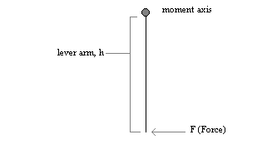
Figure 2
then the moment of F with respect to the moment-axis is Fxh, meaning, F is exerting h times at the moment-axis:

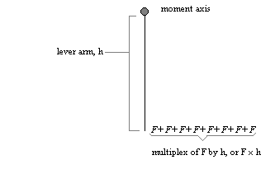

Figure 3

This concept is not new. What is new is that the PMM found out that inertia responds to a moment in the same concept.

Let us have a particle and a moment-axis and a lever arm as shown (next page):
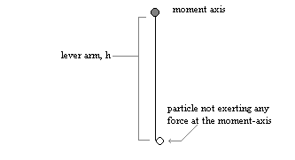
Figure 4
When the moment of the particle is taken, the particle will respond with p × h (p stands for particle), or p is responding h times at the moment-axis:

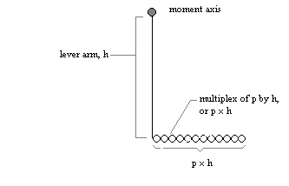
Figure 5
If inertia is defined as the internal resistance of a body to any external circumstances, then p × h is the multiplex of that resistance, and not of the particle (since the particle did not increase in number), with respect to a moment-axis.

Now, since the multiplex of the inertia of p is so small, I represented p × h, or the multiplex, with a line and called it particle inertia intensity as shown below:
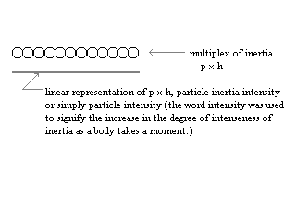
Figure 6

P × h is actually the first moment of inertia of the particle from a moment-axis. If we have a number of particles about a moment-axis, we can create an image of the first moment of inertia of the particles by combining the linear representations of p × h or the particle intensities. Let us take for example a rectangular strip, b × h, moment-axis at the top and divided into unit areas b' × h', where b' is b divided by unspecified number of divisions of b (assumingly large to highlight the minuteness of the particle), and h' is h divided by an unspecified number of divisions of h:

$b'=b/\text{no}\text{.}$ of divisions of b
$h'=b/\text{no}\text{.}$ of divisions of h

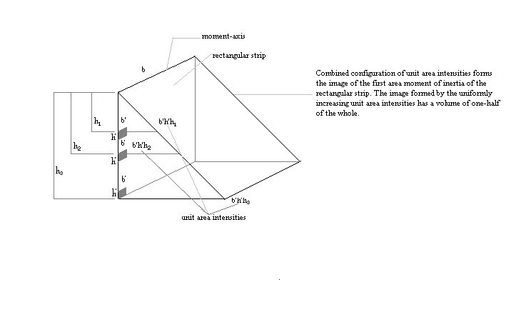
Figure 7

The summation of the unit area intensities, ∑ b'h'h, is equal to b'h'h multiplied by the number of divisions of b and h and then multiplied by ½:

∑ b'h'h = b' (no. of divisions of b) × h' (no. of divisions of h) × h × ½ ,

(half of the whole of a rectangular prism)

$$\sum{b'h'h=\frac{{\text{bh}}^{2}}{2}}$$

To get the value of the second area moment of inertia, I assumed that the unit area intensities also behave within the boundary of physical laws: that the configuration has a centroid and the summation of the unit area intensities act at the centroid.

Thus, for a second area moment of inertia, known by the variable I, multiply ∑ b'h'h by the distance of the centroid of the summation of unit area intensities from the moment-axis:
$\begin{aligned}I=\sum{b'h'h\left(\frac{2h}{3}\right)} \\ I=\frac{{\text{bh}}^{2}}{2}\left(\frac{2h}{3}\right) \\ I=\frac{{\text{bh}}^{3}}{3}\end{aligned}$
Centroid of the summation of unit area intensities from the moment axis

Evaluating the same problem using Calculus:
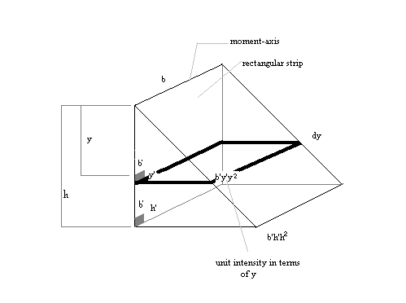
Figure 8

Since the increment of y is y' multiplied by the number of divisions of y, then:

y' (no. of divisions of y) = dy

Therefore (again, let b' signify the number of divisions of b, and h' the number of division of h):

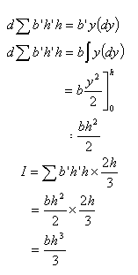

Now, to create the image and obtain the value of the second area moment of inertia of the rectangular strip, let us go back to the particle in moment. Take the particle in moment as responding to h² times at the moment-axis as shown in Figure 9:
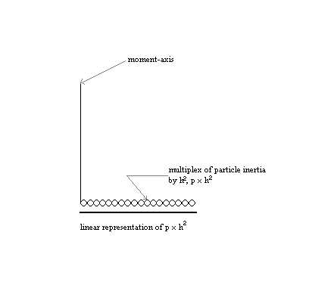
Figure 9

Giving a linear representation to p × h², combine the particle intensities to form the image of the second moment of inertia of a body in moment. Thus, for the rectangular strip b × h (Figure 10,next page):
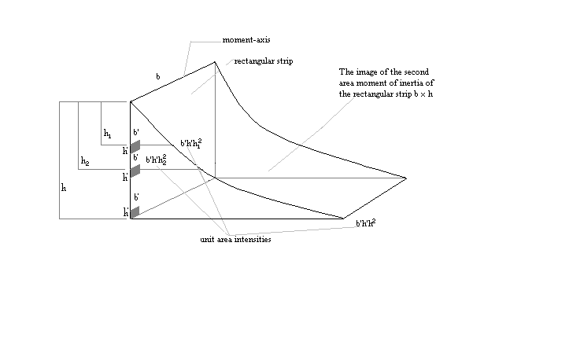
Figure 10

Again, by Integral Calculus, get the value of the second area moment of the rectangular strip through the image of the second moment of inertia:
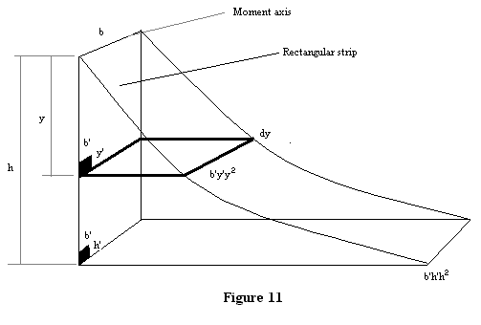

The increment of y would again be:

y’ (no.of division of y) = dy, and,

b’ (no.of division of b) = b

$$\begin{aligned}d\sum{b'h'h^{2}}={\text{by}}^{2}\text{dy} \\ \sum{b'h'h^{2}=b\int{y^{2}\text{dy}=\frac{{\text{by}}^{3}}{3}]_{0}^{h}}} \\ \sum{b'h'h^{2}=\frac{{\text{bh}}^{3}}{3}}\end{aligned}$$

Σb’h’h² is the I or the Moment of Inertia of the rectangular strip from a moment-axis at the top of the figure.

