Updated November 28th, 2009.

Novel NIR Spectroscopy and Correlation Approaches to Amino Acid and Proteins Analysis for Quality and Functionality Improvements

Table of Contents

PROJECT SUMMARY------------------------------------------------------------------------  PROJECT DESCRIPTION-------------------------------------------------------------------  Introduction and Background-----------------------------------------------------------------  Rationale and Significance --------------------------------------------------------------------  Research Objective --------------------------------------------------------------------------  Rationale, Research Questions and Hypotheses ----------------------------------------  Previous Studies and Recent Developments --------------------------------------------- | iii  1  2  4  5  6  7
Research Methods-------------------------------------------------------------------------------  Proposed Studies and Techniques, including Feasibility -------------------------------  Limitations and Advantages of Existing and Proposed Methodologies  Near Infrared Spectroscopy, Correlation Micro-spectroscopy and Hyperspectral  Imaging for Soybean Seed and Protein Composition Analysis------------------------  Evaluation and Selection of the NIR Spectroscopic Instruments----------------------  Selection of Soybean Standard Samples --------------------------------------------------  NIR Spectra and Data Pre-processing, NIR Calibration Algorithms and  Software Tools: Grams-32 and beyond----------------------------------------------------  Development and Cross-Validation of NIR Calibrations for the SpectrumOne  NTS model, FT-NIR Spectrometer---------------------------------------------------------  Applications of Results and Future Developments: Nanotechnology and  Agricultural /Medical Biotechnology Applications -------------------------------------  Limitations and Advantages of Existing and Proposed Methodologies --------------  Conclusions------------------------------------------------------------------------------------  References ----------------------------------------------------------------------------------------  Appendix A: Research Instruments and Supporting Data ------------------------------ Appendix B: Research Publications of Valentin Prisecaru: 2009 Updated List,  together with the full text of his published papers (in collaboration)-- on CD-ROM ---- Appendix C: Composition of the National Soybean Germplasm Collection ----------- | 20  20  22  26  26  27  27  28  29  34  35  36  A1  B1  C1
PROPOSED Project Summary

This proposed project is focused on improving the reliability, transferability and speed of NIR spectroscopic methods of analysis for amino acids in whole soybeans and soy proteins for food and feed precise matrix formulations. The results of this research have the potential to substantially improve agricultural efficiency, human and animal food functionality, and human health. Novel correlation approaches and techniques, such as NIR microspectroscopy, NIR-based Cross-correlation and Hyperspectral Imaging are being developed, and were also included.

Finding soybean varieties that vary in specific amino acids, such as essential, or conditionally essential, amino acids, is critical for finding new uses of specific soybean lines from the National Soybean Germplasm Collection, with improved traits for food and feed applications.

Soybean genetic selection and breeding experiments for developing high-protein, high-yield varieties, with improved amino acid and fatty acid content cultivars require rapid, economical and reliable composition analysis of protein, oil, moisture, fatty acid and amino acid levels of large sets of soybean samples. Conventional “wet chemistry” analytical methods for such soybean components are both time-consuming and costly. As a result, soybean researchers and breeders have an imperative need to utilize faster and less expensive analysis methods that the ones currently in use. Near Infrared (NIR) Spectroscopy is a rapid and inexpensive method for composition analysis for academia and industry professionals alike. Recent advancements in instrumentation design, such as the application of the Diode Array (DA) technique and the Fourier Transform Near-Infrared and Infrared (FT-NIR/FT-IR) techniques, have significantly improved the overall instrument performance and advancement in the field of grain analysis. In the following research proposal, the state-of-the-art FT-NIR instruments will be evaluated and utilized. I plan to make calibration plots of selected amino acids in soybean lines. Data analysis and calibration methodology will also be substantially improved, in order to allow rapid NIR analysis of the large number of soybean samples required for improving the genetics of soybean seed composition for agricultural cost savings and human health food applications.
Project Description

IntroductioN

background

The soybean is a very important agricultural crop in the world. More than three billion bushels of soybeans are produced in the United States each year (USDA NASS, 2007). Soybean constitutes a major source of plant protein and oil for humans and animals. Protein and oil content among different soybean cultivars can vary greatly. Climatic changes, genetics, topography, and soil fertility are the main factors influencing soybean composition, including amino acid composition in soybeans (Goldflus, 2006). Some accessions in the world soybean collection have over 50% protein on a moisture-free basis, but most commercial soybean cultivars contain only ~40% protein (Liu, 1997). Because of the high global soybean production, the development of high-protein and high-yield soybean cultivars have the potential to significantly increase the value of the soybean crop. In the breeding and genetic selection experiments that have been used to create such high-protein and high-yield cultivars, very large numbers of soybean samples are usually measured, and rapid, reliable and economical determinations of protein and oil contents, as well as other measurements of such samples, are required. Conventional, or “wet chemistry”, analytical methods for measuring major soybean components, such as the Kjeldahl method for protein content determination, and the oven-drying method for moisture content measurement, are time-consuming, expensive and impractical for measurements of large sets of soybean samples that are required for soybean breeding and genetic selection experiments. Therefore, faster and less expensive methods for protein, oil, and moisture content determination of soybeans are required for breeding and genetic selection experiments.

The soybean is the highest grain protein and oil source for the human diet. In addition to major components such as protein and oil, rapid, reliable and economical determinations of low-level components of soybeans, such as: individual amino acids, fatty acids and isoflavones are required for breeding and genetic selection of soybean cultivars for food applications; (the latter are not however included as objectives of this project proposal.)

RATIONALE AND SIGNIFICANCE

- Rationale

In order to increase the value of the soybean crop and develop high-protein, high-yield soybean cultivars that have optimized amino acid and/or fatty acid composition for human and animal food applications, rapid and reliable analytical methods are required for the determinations of protein, oil, moisture, amino acids and fatty acids of soybeans seeds. Conventional, “wet chemistry”, analytical methods for determining such components are both time consuming and costly. Therefore, faster and less expensive methods than wet chemistry ones are required for most practical applications in the agricultural, food, health food, pharmaceutical and medical fields.
NIR spectroscopy has been widely applied to the analysis of major components in grains and oilseeds since the 1960s. However, the accuracy and reliability of previous applications have been limited by the instrumentation and data analysis techniques. In order to improve the accuracy and reliability of NIR for measuring such major components, and to apply NIR for analysis of even low-level components such as isoflavones and individual amino and fatty acids, major advancements in instrumentation, as well as, data analysis and calibration methodologies are needed.
In recent years, the NIR spectroscopic instrumentation techniques have evolved significantly and have undergone major improvements over previous designs. Since 1998, novel NIR instrumentation techniques such as the application of Diode Array (DA-NIR spectrometers) and Fourier Transform (FT-NIR spectrometers) techniques have significantly improved speed, sensitivity, resolution and reproducibility in comparison with instruments employing the previous, conventional technologies. The new NIR instruments have, therefore, the potential for significantly improving the quantitation of soybean composition, as well as the quantitation of other grains and related foodstuffs, at a reasonable price.
Novel NIR instrumentation techniques, combined with improved data analysis and calibration methodologies, are essential for selecting soybean cultivars with both high quality protein composition and high agronomic yield. Such improved NIR analysis can also result in enormous cost and time savings for the amino acid composition analysis that is required by soybean breeders in genetic selection experiments.
Currently, the main goal of this preliminary proposal is to develop an accurate NIR calibration for individual amino acids, which has not been achieved by any group to date. The problem with solving 22 separate amino acids is that there are not enough known variables to accurately resolve each individual amino acid. To solve this complex problem, one needs to approach the situation differently than the previous attempts.

- Significance

The development of high-protein and-high yield cultivars is a major goal for soybean breeders and would add significant value to an already vital and well-researched global crop.
Recent discoveries regarding the health benefits of soybeans have renewed the interest in soybean research. Furthermore, both animal studies and improvement of animal feeds are greatly facilitated by FT-NIR analysis of amino acid supplementation and precision matrix formulation of improved animal feeds.

research objective

To design and develop improved multivariate analyses and approaches to NIRS calibrations for amino acid composition analysis of soybean proteins, soybeans and soybean food and feed matrix formulations, and develop NIRS calibration transfer methodology between different laboratories for various food and feed applications. The focus is on correlation methods and techniques, as well as multivariate analyses that are very important for such improvements.

specific AIMs
The following specific aims need to be addressed in order to achieve the overall research objective of the proposal, and thus also realize the utility of NIRS in practical food and feed applications, as well as laboratory analysis:

- To generate NIRS amino acid residue calibrations for a selected group of three amino acids, based on new approaches to sample standard selections involving correlation analysis of primary data, as well as improved primary techniques for several amino acids.
- To investigate the potential of an amino acid triple matrix method for developing NIRS calibrations for amino acids and amino acid mixtures in soybean seeds and amino acid mixtures (v. Table 1 on the next page).
- To obtain NIRS calibrations for several, additional selected groups of three amino acid (residue) triplets, such as Phe-Leu-Lys and Asx-Ala-Leu. To compare reduced and unreduced soybean protein calibrations, to improve the cysteine vs. cystine NIR calibrations.
- To compare the results that I obtained in our Physical Chemistry of Foods laboratory with the results of other laboratories’ data in order to investigate the transferability of NIRS calibrations among different laboratories. This is key to the wide acceptance of NIRS as an effective and inexpensive analysis method in Food Chemistry and Agronomical laboratories.
- To obtain accurate values of AAs that are appropriate for use in precision formulation matrices.
- To develop improved methodology for NIR spectra pre-processing and data analysis that increase both the accuracy and reliability of NIR measurements of soybean seed composition; to compare the calibration results obtained with the PLS-1 and PLS-2 regression algorithms in order to improve the multivariate analysis in amino acid calibrations.
- To carry out the analysis and comparison of soy proteins of similar amino acid composition in powder vs. gel vs. liquid suspension, in order to investigate the matrix effect on the NIR calibrations, as well as improve the precision of formulations for foods and feeds.

previous studies and recent developments

Soybeans and other agricultural products have been investigated by humans for a very long time. It was not until early last century, however, that we have investigated certain specific attributes of soybeans, like amino acid composition or fatty acid levels. In 1934 Csonka and Jones reported variations in the cystine, tryptophan, and tyrosine content of six varieties of soybeans, and suggested that “varieties should be selected for planting which produce more and better quality protein from the nutritional standpoint.” Doty et al. (1946) reported analyses of corn single crosses for tryptophan, tyrosine, cystine, arginine, and histidine and have concluded that the amount of these amino acids in the corn protein is related to the genetic constitution of the plant.
Later, Kuiken et al. analyzed 20 soybean varieties for the essential amino acids and glutamic acid using microbiological methods (Kuiken, 1948). The amino acid distribution was found to be quite uniform. The greatest variation occurred with methionine, where the highest value was 19% greater than the lowest. Toasting the meals (to inactivate antinutritional factors) did not result in the loss of any amino acids except lysine (approx. a ~5% loss). The loss of lysine indicated by the data was considered too small to be of nutritional significance (Kuiken, 1948). Recently, because the availability of high-throughput and inexpensive single neuclotide polymorphisms (SNP) typing systems, researchers have gained interest in the development of SNP markers. They are now analyzing diverse sets of soybean genotypes that can be successfully used for SNP discovery in coding DNA and closely associated introns and untranslated regions (Van, 2005). Major quantitative trait loci for improving soybean seed quality have now been, and are continued to be discovered (Pantheea, 2005). The following articles and discussions are directly relevant to my preliminary proposal:

        - Kovalenko, et al. (ISU). Recently, a group at Iowa State University has recently measured fatty acids (Kovalenko et al., 2006) as well as amino acids (Kovalenko et al., 2006b) using linear and non-linear calibration models using the spectrometers in Table 1.
[Source: Kovalenko et al., 2006]

Their equations were developed using partial least squares (PLS), artificial neural networks (ANN), and support vector machines (SVM) regression methods. Their research concluded that the performance of PLS and SVM was significantly better than that of ANN. Such amino acid data analysis obtained by NIR is summarized in Table 2.
Validation of prediction models resulted in r² values from 0.04 (tryptophan) to 0.91 (leucine and lysine), which agrees with previously published reports (e.g., Baianu et al., 2005). However, the Kovalenko et al., 2006, calibration standard samples only covered a relatively narrow range of protein content, and such soybean samples had no reported accession lines. This lack of non-accession lines prevents the validation of such data by independent studies. The conclusions of Kovalenko at al., 2006, are at least, in part, questionable.

Table 2. Statistics of Reference Amino Acid and Protein Concentrations
(Percentage of Total Weight on Dry Basis) in Calibration and Test
Soybean Samples Used in This Experiment (from Kovalenko, 2006b)

        - Krishnan et al., 2005. In a comparison of the amino acids of soybeans differing in protein content, soybeans with higher protein content had a significantly lower percentage of sulfur amino acids, while those with lower protein exhibited a higher content of cysteine and methionine (Krishnan et al., 2005). Nitrogen application increased the protein content but lowered that of the sulfur amino acids. Transmission electron microscopy examination of thin sections of low protein soybean seeds revealed several protein storage vacuoles that were partially filled with storage proteins. Fluorescence 2D difference gel electrophoresis of soybean proteins revealed that nitrogen application favored the accumulation of the alpha-subunit of beta-conglycinin while decreasing the accumulation of Bowman-Birk protease inhibitor (BBI), a protein rich in cysteine (Krishnan et al., 2005).

        - Kwanyuen et al., 1997. Significant difference has been discovered between 11S and 7S subunits for both Cys and Met contents of soybeans, as well as the very low existing variation for the 11S (and also possibly the 7S) amino acid composition variation that was determined genetically, which supports our claim of a correlation of amino acid content with the total protein content of soybeans (Kwanyuen et al. (1997). Almost all protein content in soybeans comes from the storage proteins, mostly 11S and 7S, which are genetically exhibiting quite low variation in amino acid content. Kwanyuen et al. (1997) reported a strong positive correlation of the 11S:7S ratio to methionine or cysteine concentration of total protein (Table 3). Moderate positive associations were also found for both threonine and tyrosine. A moderate negative correlation was found between lysine and the 11S:7S ratio. No correlation was found for leucine, phenylalanine or for the total essential amino acid concentration with the 11S:7S ratio. These results are consistent with our experimental results, as well as with the results of Kovalenko et al. (2006), that is, that amino acid content is proportional to the total protein content for most amino acids except for Cys, Met, Lys, Thre and Tyr. However, this has been verified experimentally only for the wild G. soja, and not for the commercial or standard soybean, G. max. Based on these data, G. soja may contain a different complement of genes that influence expression of 11S and 7S proteins than the G. max germplasm. Thus, through inter-specific hybridization, wild soybeans might be a useful genetic resource for the further improvement of protein quality (i.e., amino acid composition) in cultivated soybeans although such studies would be severely hindered by experimental difficulties.

Table3.
[Source: Kwanyuen et al., 1997: JAOCS, Vol. 74, no. 8 (1997)]
It is interesting to note that the most significant change in the 11S:7S ratio variation is the change in the Acidic to Basic amino acids ratio, as the ratio has been shown to vary from 1.7 to 4.9 in wild soybeans. Unfortunately, no group has ever studied these using NIR Spectroscopy, nor the expected values for important amino acids in soybeans like Cys and Met. There also exists a currently unavailable Japanese genetically-engineered mutant soybean variety that only has 11S protein. These varieties would be very worthwhile to study and our lab is currently attempting to get samples.

Note, however, that the total soybean protein content, with which the amino acid content is strongly correlated for commercial soybeans, is also governed by environmental (soil/solar/rain, etc) factors, significantly compared to the genetics, but not necessarily more than the latter.

Table 4:
[Source: Kwanyuen et al., 1997]

        - Goldflus et al., 2006. Goldflus et al. (2006) recently compared crude protein, essential and non-essential amino acid levels in soybean samples collected in several Brazilian states during the 2003-2004 harvest. Soybeans were sampled using reflectance NIR spectroscopy and nutritional differences were noted. Soybeans from three of the seven states showed higher levels of essential amino acids. However, the essential amino acid levels were not always highly correlated to the protein content. The study corroborated the theory that soybeans produced in different environmental conditions are expected to show variable protein composition and quality.

Brazil, 2003 to 2006 Summary:
- Collected soybean samples in several different states in Brazil
- Analyzed amino acids in soybeans using:
  - HPLC
  - Derivatized HPLC
- Individual amino acid compositions of the soybean samples showed significantly different amino acid mean levels (p<0.01 and p<0.02) – Met, Lys, and Thr
- Tentative Conclusion: it is possible to calculate the a.a. content of a sample for several amino acids by comparison with a primary method; however, primary data was not available for several essential amino acids.

        - Hernández-Sebastià et al., 2005. In this paper on free amino acids and soy protein content of soybeans, high correlations were noted for Gln and Asn with soy protein content, as well as the high percentage of Gln+Asn+Leu in the Free amino acid pool. The amino acid tables from the article are shown below (tables 1 and 2 below). The authors utilized several approaches to examine the role of N-assimilate supply in the control of soybean composition. In the first study where developing seeds were grown using varying concentrations of Gln, light stimulated carbon flux into oil and protein, and was required to sustain various anabolic processes under high nitrogen supply (Hernández-Sebastià et al., 2005). A higher than average Gln supply maybe have caused higher transcript levels of beta-conglycinin and oleosin. In the second study, soluble amino acid pools in related low- and high-seed protein lines showed that, in the light, the high-seed variety accumulated higher levels of Asn and several other amino acids in developing cotyledons compared with lower protein variety; however, at the seed coat and apoplast levels both lines appeared similar. In the dark, the low-protein line accumulated Gln, Arg and its precursors, which could be explained by a reduced availability of organic acids required for amino acid enzymatic conversions, while the hi-protein line maintained higher levels of the pyruvate-derived amino acids (i.e., Val, Leu and Ile) (Hernández-Sebastià et al., 2005).
In comparing the low and protein amino acids, seed composition differences were observed in steady-state transcript levels of storage proteins and the lipogenic, multi-subunit enzyme acetyl CoA carboxylase. Next, a positive correlation (P < = 0.05) between free Asn in developing cotyledons and seed protein content upon maturity was confirmed in a comparison of five unrelated field (i.e., not in vitro) cultivars (Hernández-Sebastià et al., 2005). These findings indicate that high seed-protein in soybean is determined by the capacity of the embryo to engage in nitrogen uptake and manufacture storage proteins. Asn levels are likely tightly regulated in the embryo of the high-protein varieties, and may play a role as a metabolic signal of seed nitrogen status (Hernández-Sebastià et al., 2005).

Table 5. Amino acid content (nmol mg^{–1} FW) in seed coats of soybean embryos harvested 15 d after flowering
Cultivar | Photoperiod | Asn | Gln | Glu | Arg | His | Citrulline | Asp | GABA | Ala | Pro | Gly | Thr | Ser
NC 103 | 9 h light | 14.1 | 6.4 | 3.0 | 1.1 | 0.8 | 0.5 | 1.5 | 5.9 | 1.9 | 0.37 | 0.74 | 0.83 | 1.40
 | 3 h dark | 12.7 | 1.8 | 3.1 | 1.2 | 0.3 | 0.4 | 1.6 | 3.8 | 1.1 | 0.27 | 0.37 | 0.35 | 0.95
NC 106 | 9 h light | 13.9 | 6.7 | 1.4 | 1.1 | 0.8 | 0.5 | 1.3 | 8.1 | 1.7 | 0.40 | 0.50 | 0.90 | 1.70
 | 3 h dark | 12.1 | 2.4 | 1.1 | 1.4 | 0.6 | 0.2 | 1.1 | 4.5 | 0.9 | 0.23 | 0.26 | 0.51 | 1.09
Source of variation | d.f. | ANOVA P values
Cultivar (C) | 1 | n.s. | 0.005 | 0.03 | n.s. | n.s. | n.s. | n.s. | n.s. | 0.01 | n.s. | n.s. | n.s. | n.s.
Photoperiod (P) | 1 | n.s. | 0.0001 | n.s. | n.s. | n.s. | n.s. | n.s. | 0.08 | 0.0009 | n.s. | 0.03 | 0.03 | 0.01
CxP | 1 | n.s. | 0.06 | n.s. | n.s. | n.s. | n.s. | n.s. | n.s. | n.s. | n.s. | n.s. | n.s. | n.s.
Error | 5

Cultivar | Photoperiod | Val | Met | Ileu | Leu | Tyr | Phe | Lys | Orn | ANBA | Total amino acids
NC 103 | 9 h light | 0.49 | 0.14 | 0.20 | 0.23 | 0.06 | 0.20 | 0.31 | 0.06 | 0.31 | 40.2
 | 3 h dark | 1.55 | 0.00 | 0.04 | 0.10 | 0.00 | 0.04 | 0.32 | 0.04 | 0.14 | 28.8
NC 106 | 9 h light | 0.47 | 0.17 | 0.20 | 0.24 | 0.07 | 0.17 | 0.38 | 0.09 | 0.44 | 41.3
 | 3 h dark | 0.34 | 0.09 | 0.17 | 0.26 | 0.00 | 0.11 | 0.46 | 0.09 | 0.26 | 28.1
Source of variation | d.f. | ANOVA P values
Cultivar (C) | 1 | n.s. | 0.0001 | n.s. | n.s. | n.s. | n.s. | n.s. | n.s. | n.s. | n.s.
Photoperiod (P) | 1 | n.s. | 0.0001 | n.s. | n.s. | 0.03 | n.s. | n.s. | n.s. | n.s. | 0.01
CxP | 1 | n.s. | 0.0001 | n.s. | n.s. | n.s. | n.s. | n.s. | n.s. | n.s. | n.s.
Error | 5

Legend: Seed coat was about 35 mg FW. Values in bold are statistically significant with the probabilities shown below. ANBA, amino N-butyric acid; n=2; d.f., degrees of freedom; n.s., not significant (P >0.05). [Source: Hernández-Sebastià et al., 2005].
Table 6. Amino acid content (nmol seed^{–1}) in the apoplast after a 3 h collection of assimilates released into phytagel traps
Cultivar | Photoperiod | Asn | Gln | Glu | Arg | His | Citrulline | Asp | GABA | Ala | Pro | Gly | Thr | Ser
NC 103 | 3 h light | 354 | 98 | 16 | 25 | 18 | 8 | 35 | 402 | 67 | 24 | 21 | 26 | 52
 | 3 h dark | 449 | 46 | 10 | 30 | 13 | 6 | 39 | 431 | 91 | 8 | 15 | 23 | 49
NC 106 | 3 h light | 388 | 145 | 16 | 27 | 37 | 11 | 34 | 355 | 69 | 25 | 17 | 28 | 60
 | 3 h dark | 378 | 96 | 14 | 34 | 19 | 1 | 38 | 264 | 73 | 13 | 13 | 28 | 52
Phytagel blank |  | 0 | 0 | 0 | 0 | 0 | 0 | 2 | 0 | 1 | 0 | 2 | 0 | 1
Sources of variation | d.f. | ANOVA P values
Cultivar (C) | 1 | n.s. | 0.006 | n.s. | n.s. | 0.0001 | n.s. | n.s. | 0.0594 | n.s. | n.s. | n.s. | n.s. | n.s.
Photoperiod (P) | 1 | n.s. | 0.004 | 0.07 | n.s. | 0.0001 | 0.02 | n.s. | n.s. | n.s. | 0.0008 | 0.03 | n.s. | n.s.
CxP | 1 | n.s. | n.s. | n.s. | n.s. | 0.0010 | n.s. | n.s. | n.s. | n.s. | n.s. | n.s. | n.s. | n.s.
Error | 23

Cultivar | Photoperiod | Val | Met | Ileu | Leu | Tyr | Phe | Lys | Total amino acids
NC 103 | 3 h light | 20 | 6 | 12 | 18 | 7 | 12 | 15 | 1236
 |  | 19 | 4 | 10 | 16 | 8 | 12 | 17 | 1296
NC 106 | 3 h light | 22 | 9 | 13 | 19 | 7 | 12 | 17 | 1311
 |  | 21 | 4 | 12 | 15 | 8 | 13 | 18 | 1114
Phytagel blank |  | 0 | 0 | 0 | 0 | 0 | 0 | 0 | 6
Sources of variation | d.f. | ANOVA P values
Cultivar (C) | 1 | n.s. | n.s. | n.s. | n.s. | n.s. | n.s. | n.s. | n.s.
Photoperiod (P) | 1 | n.s. | 0.002 | n.s. | 0.04 | n.s. | n.s. | n.s. | n.s.
CxP | 1 | n.s. | n.s. | n.s. | n.s. | n.s. | n.s. | n.s. | n.s.
Error | 23

Soybean embryos were surgically removed from their seed coats 15d after flowering as described by Thorne and Rainbird (1983). Values in bold are statistically significant with the probabilities shown below. n=4; d.f., deg freedom; n.s., not significant (P >0.05). [Source: Hernández-Sebastià, 2005].
        - Taylor M. at al., 2008. In a study of the common bean (or kidney bean, phaseolus vulgaris), it was found that seed storage protein deficiency may improve sulfur amino acid content, by a method involving the redirection of sulfur from γ-Glutamyl-S-methyl-cysteine (Taylor, 2008). Methionine and cystine levels, measured in mg per g protein, were increased by up to ~40%, to levels slightly above the Food and Agriculture Organization (United Nations) guidelines on amino acid requirements for human nutrition.

        - Petter C.H., 2008. Near infrared spectroscopy compared to liquid chromatography coupled to mass spectrometry and capillary electrophoresis as a detection tool for peptide reaction monitoring. NIRS proved to be highly suitable for the detection of newly formed conjugates after separating them on a thin layer chromatography (TLC) plate. The recorded fingerprint in the near infrared region allows for a selective distinct qualitative identification of conjugates without the need for expensive instrumentation such as quadrupole or MALDI-TOF mass spectrometers (Petter, 2008).

        - Qiao Y., et al., 2004. In a comparison of three infrared spectroscopy techniques for routine evaluation of AA in animal meals, meals (n =54) with known amino acid contents were scanned with NIR, mid-FTIR and Raman IR spectrometers. For NIR and Raman, samples were scanned “as is”, but for FTIR, samples had to be finely ground first, in order to obtain reasonably accurate spectra (Qiao, 2004). Utilizing derivatized spectral data, calibrations for certain nutritionally important amino acids could be developed that were equivalent for both NIR and FTIR.

Table 7. Summary of amino acid composition data (%) of the studied animal meals (n = 54; samples were selected for heterogeneity)
[Source: Qiao, 2004].

The variation across the amino acids tested explained by these calibrations was 70% for NIR and 68% for FT-IR. Removing spectral data between 4,000 and 2,000 cm−1 from the FT-IR data generally improved calibrations with prediction errors lower than with NIR. However, FT-IR calibrations contained fewer samples than did NIRS calibrations (~40 vs. 48), because more samples were removed as outliers (Qiao, 2004). Raman did not yield acceptable spectra for animal meals. Using the entire mid-infrared range, FTIR calibrations were comparable to NIRS calibrations.

Table 8. Calibration statistics obtained for amino acids in animal meals using near infrared spectroscopy (NIRS), Fourier transform (FT-IR) spectroscopy, or a portion of the FT-IR spectra.
[Source: Qiao, 2004].

Calibrations for FT-IR were improved by eliminating wave numbers that exhibited more noise, resulting in prediction errors better than those for NIRS. Thus, FT-IR has the potential to yield better calibrations for amino acids in animal meals than NIRS, but it requires greater care in sample preparation and scanning (Qiao, 2004). The authors of this article were actually able to obtain the FT-NIR spectra and predict the levels of amino acids in meat. The best coefficients of determination were: Cys, R² = 0.84 (R>92%), and Leu: R² = 0.86 (R ~ 93%).

        - Orf, J.H. In 1997 Dr. Orf’s group published an article that attempted to determine the potential use of NIR spectroscopy for amino and fatty acid analysis in soybean, comparing ground and whole samples, for 90 NIR calibration and 26 validation samples. Seventeen amino acid NIRS equations for both ground seed and whole-seed soybean samples were determined using the calibration samples. Validation of these equations showed a wide range for bias (–1.7 to 3.2 g kg–1), SEP corrected for bias (1.4 to 13.1 g kg–1), coefficient of determination (0.38 to 0.85) for all ground-seed NIR equations, and a broad range for bias (–3.1 to 4.2), SEP (2.6 to 17.8), and R² (0.06 to 0.83) for all whole-seed NIR equations. It was concluded that NIR spectroscopy could be used as a gross screening method for many amino and fatty acids contained in soybean seed. Additionally, NIR was more accurate for amino and fatty acid analysis of ground-seed than whole seed soybean samples.

PRELIMINARY DATA AND ANALYSIS

Amino acid residue contents of soybeans were determined by ¹³C liquid-state, high-resolution NMR, ion exchange chromatography and HPLC (Baianu et al., 2005; Augustine and Baianu, 1984), and I then calculated the correlations between the amino acid contents and the soybean protein content as dry weight. I have also measured the soybean protein, oil and moisture contents of all the latter samples shown in the graph of Figure 1.
The total, aggregate number of NIR measurements that I performed so far is on the order of 4,000. Amino acid residue and fatty acid profiles of a set of 3,618 standard soybean seed samples were determined by IEC and/ or HPLC coupled with GC-MS in a collaboration effort with the USDA Northern Regional Research Center in Peoria, Illinois. The NIR values for protein and oil of this 3,618 standard sample set are highly correlated, as shown in Fig. 2.
Furthermore, I have found that the contents for four amino acid residues of this standard soybean seeds set, calculated on a dry basis as a percent of the total soybean seed sample weight (D %, AA) are highly correlated with the soybean protein content calculated on a dry basis from the total sample weight (as shown in the following Figures 3 to 6). Therefore, the data presented here in Figures 3 to 6 imply that NIR calibrations for amino acid contents of soybeans may encounter a major obstacle with most standard sets because of the very high correlation (>85%) between the amino acid residue content and the protein content of soybeans. I also found lower correlations for other amino acid residue contents, such as: Asx, His, Ala, Ile, Cys and Met, which were determined by primary methods which required acid hydrolysis of soybean proteins.
Table 9 presents a comparison between our amino acid composition analyses by ¹³C Liquid-State, High-Resolution NMR of un-hydrolyzed soybean seed samples and the corresponding data obtained by ion exchange chromatography of extracted soybean proteins after acid hydrolysis. As shown in an early report (Augustine and Baianu, 1985), there is very good agreement between the amino acid analysis of acid hydrolyzed, extracted soybean protein samples by ¹³C Liquid-State, High-Resolution NMR and the corresponding data obtained by ion exchange chromatography of the same extracted soybean protein samples after acid hydrolysis. Therefore, the remaining differences between the results obtained by the two different approaches are most likely to be caused by acid hydrolysis. Furthermore, our NMR results include data for Trp, Gln, Glu, Asn and Asp in un-hydrolyzed soybean proteins that cannot be obtained for acid hydrolyzed protein samples.
Table 9. Comparison between Amino Acid Contents of Soybean Proteins in Soybean Seeds Determined by ¹³C Liquid-State, High-Resolution NMR and Ion Exchange Chromatography.

Wt % Total : Ala Val Leu Ileu Gly Asn Asp Asx Gln Glu Glx
NMR 5 5 7 4.5 4 7 5 12 11 8 19
IEC 4 5.2 7.3 4.7 2.8 ND ND 12.1 ND ND 21.3
Ser Thr Arg Lys Trp Tyr His Phe Cys Met
NMR 5 4 8 7 1 3 3 6 1.5 1.0
IEC 4.6 3.6 9.5 7.8 ND 3.5 2.6 5.5 ND 0.9
[Source: Baianu, Costescu and Prisecaru, 2005].

Fig. 1. The Inverse Correlation between Protein (Dry weight %) vs. Oil (Dry weight %) for a set of 65 standards of soybean seeds that were selected for the NIRS AA-Calibration (in addition to the remaining 35 standards employed for independent validation).

Fig. 2. Arginine as % Tot Dry Wt. vs. D% Protein. Note the very high degree of correlation between the Arginine residue content (as % of Total dry weight) and the Protein (as % of Total Dry weight) for the 65 amino acid standards measured.

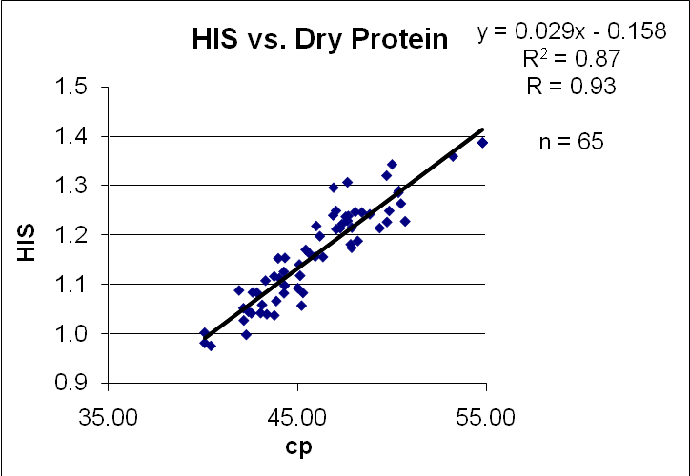
Fig. 3. Histidine as % Tot Dry Wt. vs. D% Protein. Note the very high degree of correlation between the Arginine residue content (as % of Total dry weight) and the Protein (as % of Total Dry weight) for the 65 amino acid standards measured.
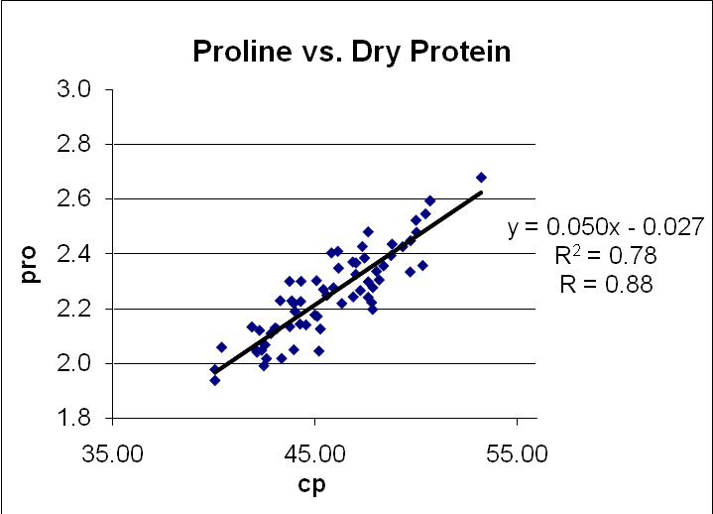
Fig. 4. Proline as % Tot Dry Wt. vs. D% Protein for 66 amino acid standards. Proline is a closely-associated imino acid.

Fig. 5. Glutamine plus Glutamic Acid (Glx), as % Tot Dry Wt. vs. D% Soybean Protein. Note the high degree of correlation between Glx% and Dr Protein% for 65 amino acid standards measured. With some measurement techniques, it is impossible to determine these two amino acids individually, so the addition is used.
Fig.6. Leucine as % Total Dry Wt. vs. D% Protein. Note the very high degree of correlation between the Leucine residue content (as % of Total dry weight) and the Protein (as % of Total Dry weight) for the 65 amino acid standards measured.

Fig. 7. Valine as % Total Dry Weight vs. D% Protein. Note the very high degree of correlation between the Valine content (as % of Total dry weight) and the Protein (as % of Total Dry weight) for the 65 amino acid standards measured.

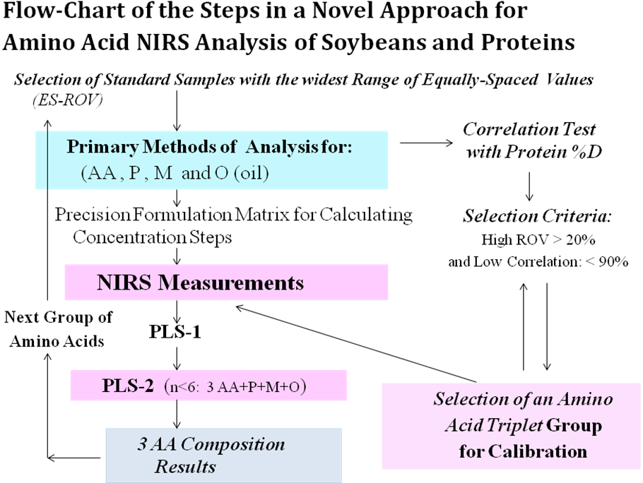

Fig. 8. Flow-chart of the novel Correlation Approach for amino acid calibration in soybeans. It is possible that this methodology could work with other food and feed systems as well.

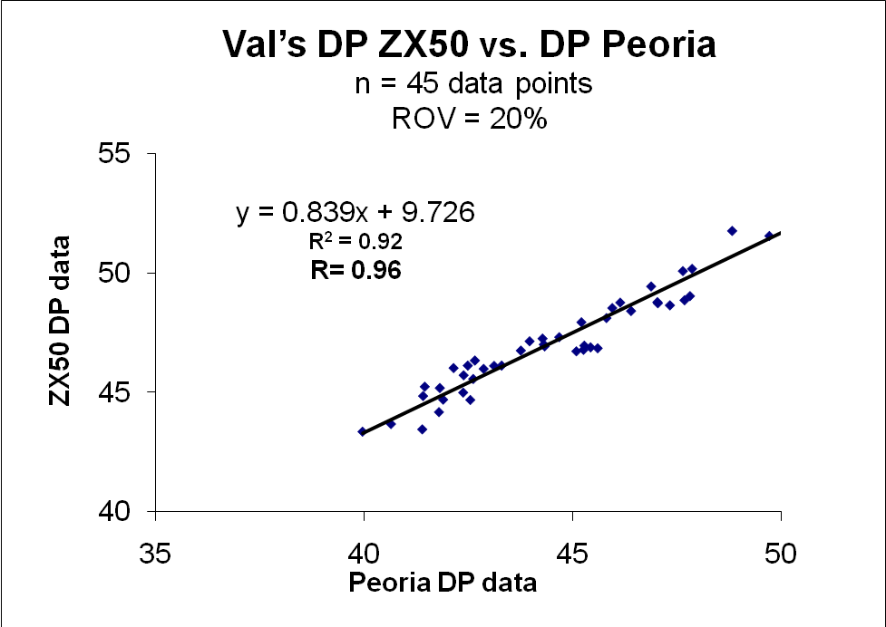

Fig. 9. Comparison of Different Laboratory Data for % Dry Soy Protein: NIR Soy Protein Data vs. Primary data (obtained by the Sigma Method–Lowry modified; the NIR protein calibration was also based on the same primary method, with recent improvements). Note the very high degree of correlation between the two sets of laboratory data for soybean proteins.
This data indicates that the range of amino acid residue content variation among different soybean lines is relatively narrow, thus limiting the scope of both NIR calibrations and of soybean line selection for improved amino acid profiles. This interesting aspect requires further experimental studies, as well as careful analysis of the NIR data for the amino acid standard sets (for example, the deconvolution of the soybean protein spectra and their comparison, as well as their correlation with the deconvoluted NIR spectra of the individual amino acids).

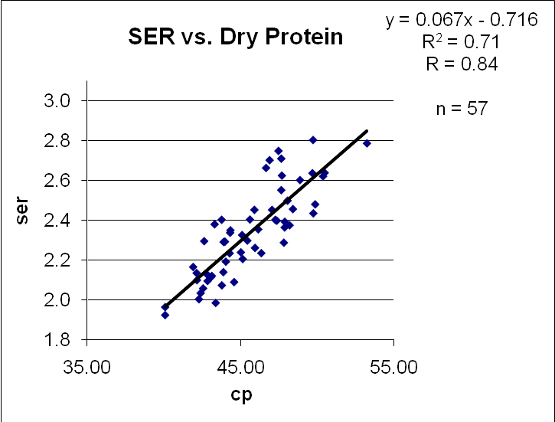
Fig. 10. Serine as % Total Dry Weight vs. D% Protein. Note the high degree of correlation between the Serine content (as % of Total dry weight) and the Protein (as % of Total Dry weight) for the 65 amino acid standards measured.

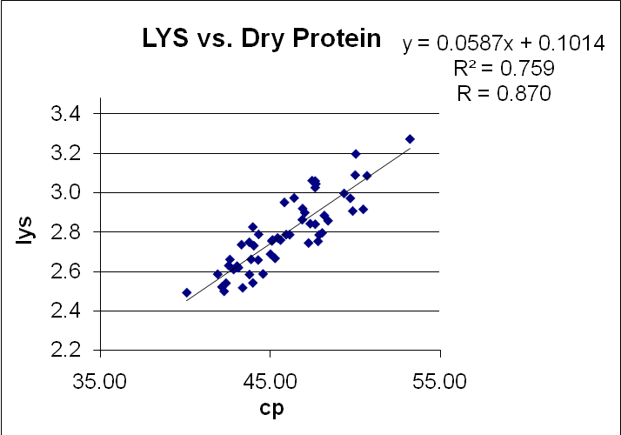
Fig. 11. Lysine as % Total Dry Weight vs. D% Protein. Note the high degree of correlation between the Lysine content (as % of Total dry weight) and the Protein (as % of Total Dry weight) for the 65 amino acid standards measured.
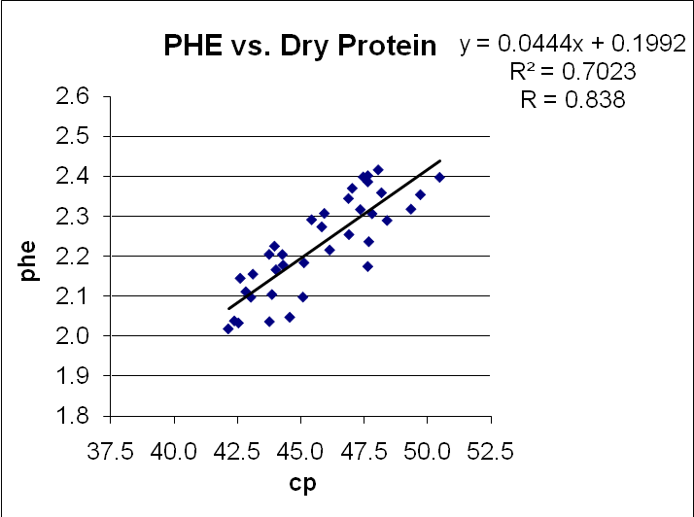
Fig. 12. Phe as % Total Dry Weight vs. D% Protein. Note the high degree of correlation between the Phe content (as % of Total dry weight) and the Protein (as % of Total Dry weight) for the 65 amino acid standards measured.

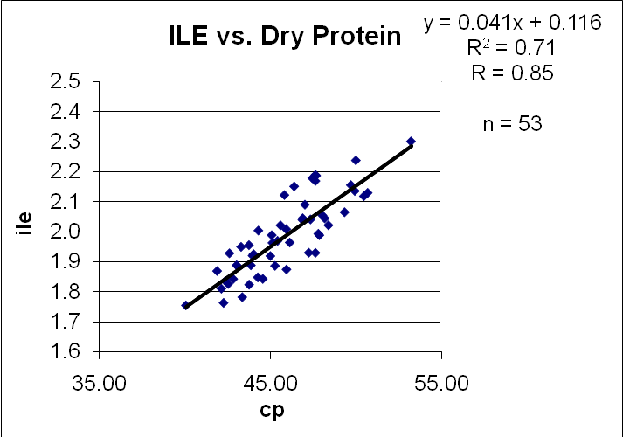
Fig. 13. Ile as % Total Dry Weight vs. D% Protein. Note the high degree of correlation between the Ile content (as % of Total dry weight) and the Protein (as % of Total Dry weight) for the 65 amino acid standards measured.

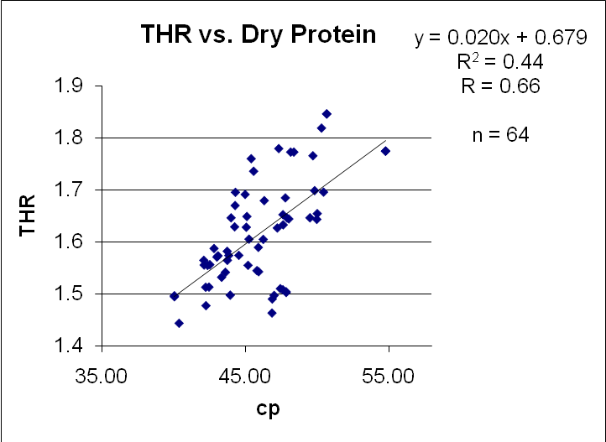
Fig. 14. Thr as % Total Dry Weight vs. D% Protein. Note the low degree of correlation between the Thr content (as % of Total dry weight) and the Protein (as % of Total Dry weight) for the 65 amino acid standards measured.

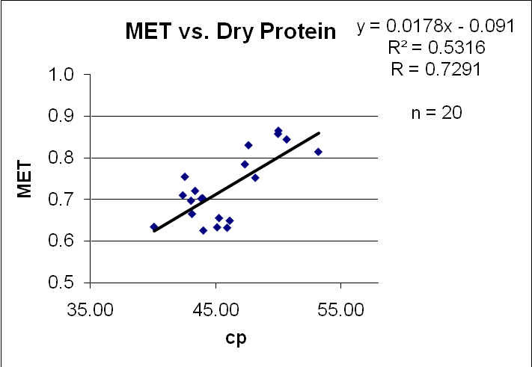
Fig. 15. Met as % Total Dry Weight vs. D% Protein. Note the lower degree of correlation between the Met content (as % of Total dry weight) and the Protein (as % of Total Dry weight) for the 65 amino acid standards measured, in comparison with either His or Arg.

Table. 10. Correlations of Amino Acid Residues with Soybean % Dry Protein in Whole Soybeans.

A.A. | R² | R |  | A.A. | R² | R
HIS | 0.84 | 0.93 |  | ILE | 0.71 | 0.85
TYR | 0.82 | 0.91 |  | GLY | 0.71 | 0.84
ARG | 0.81 | 0.90 |  | SER | 0.71 | 0.84
ASX | 0.79 | 0.89 |  | PHE | 0.70 | 0.84
GLX | 0.78 | 0.88 |  | CYS | 0.63 | 0.80
PRO | 0.78 | 0.88 |  | ALA | 0.58 | 0.76
VAL | 0.76 | 0.87 |  | MET | 0.53 | 0.73
LYS | 0.76 | 0.87 |  | THR | 0.44 | 0.66
LEU | 0.72 | 0.85

Table. 11. Summary of Amino Acids that are Very Highly-Correlated with the Dry Protein Conten, Leucine that is borderline, and the Imino Acid Proline.

- Histidine: R = 0.93
- Arginine: R = 0.90
- Glx: R = 0.88
- Valine: R = 0.87
================================
The imino acid Proline: R = 0.88
- (Leucine: R = 0.85 à borderline-high)

Table 12. Amino Acid Primary Data: shown sample is only of 401 data points-- out of an aggregate total of 3,618.

# | ASP | THR | SER | GLU | PRO | GLY | ALA | VAL | ILE | LEU | TYR | PHE | HIS | LYS | ARG | MET | CYS | M+C
1 | 4.8 | 1.6 | 2.0 | 7.3 | 2.1 | 1.7 | 1.7 | 2.0 | 1.8 | 3.2 | 1.4 | 2.1 | 1.1 | 2.6 | 2.8 | 0.7 | 0.8 | 1.5
2 | 4.8 | 1.6 | 2.0 | 7.3 | 2.0 | 1.7 | 1.7 | 2.0 | 1.8 | 3.2 | 1.2 | 2.0 | 1.0 | 2.5 | 2.7 | 0.7 | 0.8 | 1.5
3 | 5.0 | 1.6 | 2.1 | 7.8 | 2.1 | 1.8 | 1.8 | 2.0 | 1.9 | 3.2 | 1.3 | 2.1 | 1.1 | 2.7 | 3.1 | 0.7 | 0.8 | 1.5
4 | 4.8 | 1.6 | 2.1 | 7.5 | 2.0 | 1.7 | 1.7 | 2.0 | 1.9 | 3.2 | 1.3 | 2.1 | 1.1 | 2.6 | 3.0 | 0.7 | 0.7 | 1.4
5 | 4.9 | 1.6 | 2.1 | 7.4 | 2.1 | 1.8 | 1.8 | 2.0 | 1.9 | 3.2 | 1.2 | 2.1 | 1.0 | 2.6 | 2.8 | 0.7 | 0.8 | 1.5
6 | 4.9 | 1.6 | 2.1 | 7.6 | 2.1 | 1.8 | 1.8 | 2.0 | 1.9 | 3.2 | 1.2 | 2.2 | 1.1 | 2.6 | 3.0 | 0.7 | 0.7 | 1.4
7 | 5.3 | 1.8 | 2.4 | 8.4 | 2.4 | 1.9 | 1.9 | 2.1 | 2.0 | 3.4 | 1.5 | 2.2 | 1.2 | 2.8 | 3.5 | 0.6 | 0.8 | 1.5
8 | 5.0 | 1.6 | 2.1 | 7.8 | 2.2 | 1.8 | 1.8 | 2.1 | 1.9 | 3.3 | 1.4 | 2.1 | 1.1 | 2.7 | 3.1 | 0.7 | 0.8 | 1.5
9 | 5.1 | 1.7 | 2.3 | 7.9 | 2.2 | 1.9 | 1.9 | 2.1 | 2.0 | 3.3 | 1.3 | 2.2 | 1.1 | 2.7 | 3.1 | 0.7 | 0.9 | 1.7
10 | 5.7 | 1.4 | 2.7 | 9.1 | 2.3 | 2.1 | 2.0 | 2.2 | 2.2 | 3.6 | 1.6 | 2.4 | 1.2 | 3.0 | 3.7 | 0.8 | 1.0 | 1.9
11 | 6.2 | 1.6 | 2.9 | 9.7 | 2.5 | 2.2 | 2.6 | 2.3 | 2.2 | 3.9 | 1.6 | 1.8 | 1.3 | 3.1 | 4.1 | 0.9 | 1.0 | 1.9
12 | 6.1 | 1.7 | 2.8 | 9.5 | 2.5 | 2.2 | 2.1 | 2.4 | 2.3 | 3.8 | 1.7 | 2.5 | 1.4 | 3.2 | 4.2 | 0.9 | 1.1 | 1.9
13 | 5.9 | 1.5 | 2.8 | 9.3 | 2.4 | 2.1 | 2.0 | 2.3 | 2.2 | 3.8 | 1.6 | 2.5 | 1.2 | 3.1 | 3.8 | 0.9 | 1.1 | 1.9
14 | 5.2 | 1.5 | 2.4 | 8.3 | 2.2 | 1.9 | 1.9 | 2.1 | 2.0 | 3.4 | 1.4 | 2.1 | 1.2 | 2.8 | 4.7
15 | 6.0 | 1.5 | 2.8 | 9.2 | 2.3 | 2.1 | 2.1 | 2.3 | 2.2 | 3.8 | 1.5 | 2.4 | 1.3 | 3.0 | 4.1
16 | 5.7 | 1.5 | 2.7 | 8.8 | 2.4 | 2.0 | 2.0 | 2.3 | 2.0 | 3.6 | 1.6 | 2.3 | 1.2 | 2.9 | 4.0
17 | 6.0 | 1.5 | 2.8 | 8.7 | 2.3 | 2.0 | 2.0 | 2.2 | 2.1 | 3.6 | 1.6 | 2.4 | 1.2 | 2.9 | 3.9
18 | 5.9 | 1.5 | 2.7 | 9.3 | 2.4 | 2.1 | 2.1 | 2.3 | 2.2 | 3.7 | 1.6 | 2.4 | 1.3 | 3.1 | 3.9
19 | 5.7 | 1.8 | 2.5 | 8.9 | 2.4 | 2.0 | 2.0 | 2.2 | 2.1 | 3.6 | 1.6 | 2.4 | 1.2 | 3.0 | 3.8
20 | 5.8 | 1.4 | 2.8 | 9.1 | 2.6 | 2.0 | 2.0 | 2.2 | 2.2 | 3.7 | 1.6 | 2.4 | 1.4 | 3.0 | 3.8
21 | 5.9 | 1.8 | 2.6 | 9.3 | 2.5 | 2.1 | 2.0 | 2.3 | 2.2 | 3.8 | 1.6 | 2.2 | 1.2 | 3.0 | 3.8
22 | 5.7 | 1.8 | 2.5 | 8.9 | 2.4 | 2.1 | 2.0 | 2.3 | 2.1 | 3.7 | 1.5 | 2.4 | 1.2 | 3.0 | 3.8
23 | 5.6 | 1.7 | 2.3 | 8.5 | 2.2 | 1.9 | 1.9 | 2.1 | 2.0 | 3.5 | 1.5 | 2.3 | 1.2 | 2.8 | 3.7
24 | 5.3 | 1.4 | 2.6 | 8.2 | 2.2 | 1.9 | 1.9 | 2.1 | 2.0 | 3.4 | 1.5 | 2.2 | 1.2 | 2.8 | 3.5
25 | 5.4 | 1.6 | 2.4 | 8.4 | 2.3 | 1.9 | 1.9 | 2.1 | 2.0 | 3.4 | 1.4 | 2.2 | 1.1 | 2.7 | 3.5

Table 13. Ranges of Values for Amino acid residues (ROVs)

AA | ARG | PHE | CYS | TYR | ALA | SER | M+C | MET | THR
Max | 4.67 | 2.53 | 1.08 | 1.66 | 2.57 | 2.90 | 1.95 | 0.88 | 1.82
Min | 2.73 | 1.54 | 0.72 | 1.11 | 1.72 | 2.04 | 1.38 | 0.65 | 1.35
Ratio | 0.41 | 0.39 | 0.34 | 0.33 | 0.33 | 0.30 | 0.29 | 0.27 | 0.26
AA | HIS | GLX | PRO | ASX | ILE | LEU | GLY | LYS | VAL
Max | 1.36 | 9.67 | 2.60 | 6.20 | 2.27 | 3.89 | 2.18 | 3.20 | 2.37
Min | 1.00 | 7.23 | 1.95 | 4.73 | 1.78 | 3.06 | 1.72 | 2.52 | 1.90
Ratio | 0.26 | 0.25 | 0.25 | 0.24 | 0.22 | 0.21 | 0.21 | 0.21 | 0.20
Legend: |  | Red  (poor; low) |  | Green (acceptable) |  | Blue  (good; high)

- Amino Acid Residue Correlation with Dry Protein %: Analysis and Numerical Estimates for Very Highly Correlated Amino Acids

Whereas for very highly correlated amino acid residues with dry soybean protein content it is not possible to obtain independent calibrations from those of the protein, it is possible to obtain estimates based on the correlation with the protein content of the whole soybean seeds but only for samples that have a similar distribution of such very highly correlated amino acid residues with those of the standards employed for the soybean protein calibration. In practice, such estimates can be employed with most of the commercial samples, and also with many developmental lines for increased protein or oil that exhibit similar correlations, but it cannot include any developmental lines with specifcally altered content of such amino acid residues for amino acid composition selection and improvements. Examples of such estimates are presented in the next two plots and following equations.

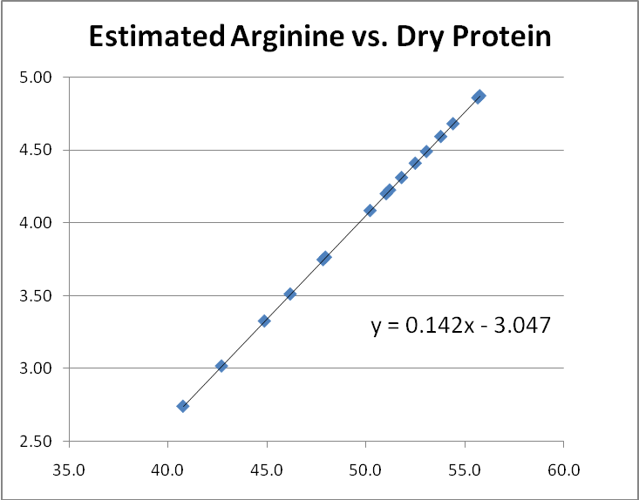
Fig. 16 . Estimated Arginine levels vs. Dry Protein.

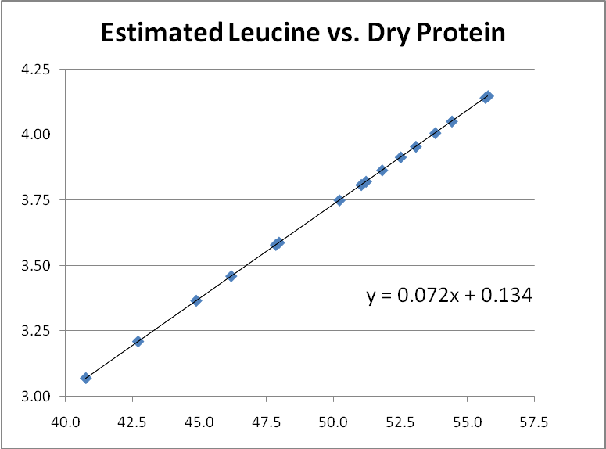
Fig.17. Estimated Leucine levels vs. Dry Protein %.

Table 15. Linear equations for estimating amino acid values.
equation for HIS |  | equation for ARG vs DP |  |  | equation for LYS
0.032x - 0.284 |  | y = 0.142x - 3.047 |  |  | 0.0587x + 0.1014
equation for PHE |  | equation for Leu
0.0444x + 0.1992 |  | 0.072x + 0.134

Table 16. Soybean Protein and Moisture Data specified with Soybean Seed Accession Identifiers

ID | v = very, lt = light, grn = green,  brn = brown, bl = black |  |  | Val’ s data  Example:  10 Data Points |  |  | TOTAL:  3,816 data points
acid | coat  color | cultivar | seed source | Prot | Moist | Oil | DP | DP  calc | DO  calc
PI536636 | Y | Ripley | 93U-5051 | 35.57 | 11.10 | 20.50 | 40.01 | 40.01 | 23.06
PI548518 | Y | Cutler 71 | 92U-901 | 36.91 | 10.00 | 20.76 | 41.00 | 41.01 | 23.07
PI548477 | Lgn | Ogden | 99S-4040 | 41.75 | 10.41 | 17.06 | 46.60 | 46.60 | 19.04
PI548379 | Y | Mandarin | 00U-109
PI548603 | Y | Perry | 98U-1459 | 41.44 | 10.30 | 10.02 | 46.20 | 46.20 | 11.17
PI533655 | Y | Burlison | 95U-2238 | 41.10 | 10.16 | 18.60 | 45.75 | 45.75 | 20.70
PI548311 | Y | Capitol | 97U-2231 | 36.71 | 9.12 | 20.60 | 40.40 | 40.39 | 22.67
PI548659 | Y | Braxton | 94S-6 | 38.03 | 10.84 | 20.24 | 42.65 | 42.65 | 22.70
PI567551 | ltGn,  1/10 blk | Huang li | 94U-785 | 39.52 | 10.44 | 19.34 | 44.13 | 44.13 | 21.59
PI458057 | Dk Gn |  | 96U-2173 | 40.17 | 9.04 | 18.80 |  | 44.16 | 20.67
PI567704 | Y, 1/2 brn | Fu yang (23) | 93U-2482 | 40.67 | 10.25 | 18.30 | 45.31 | 45.31 | 20.39

Figs.18. New FT-NIRS Calibration Results for the Amino Acid residue Phenylalanine obtained with the program TQAnalyst (based on the software package Grams32) showing the correlation plots for: Soybean Protein (component 1, C1), Phenylalanine (Phe-- component C2) and Arginine residue (Arg—component C3). (The instrument utilized to collect all data was the FT-NIR spectrometer model SpectrumOneNTS at 4 cm⁻¹ resolution and automatic accumulated scans for each yellow coat whole soybean sample.)

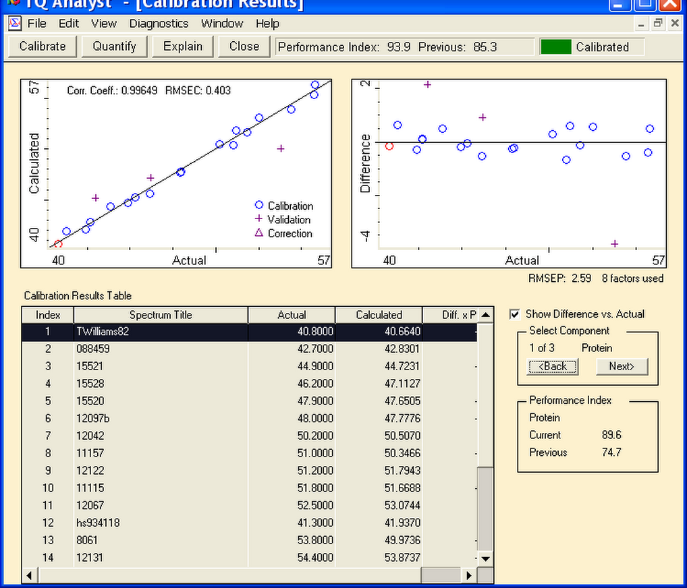

Fig.18A: Soybean Protein Calibration: Correlation Plot

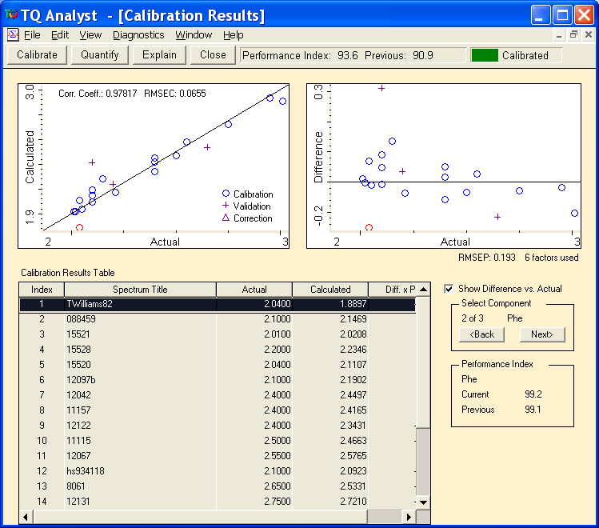

Fig.18B. New Calibration Results for the Amino Acid Residue Phenylalanine: Correlation Plot for component C2 (other conditions are as stated in Figure 18A).

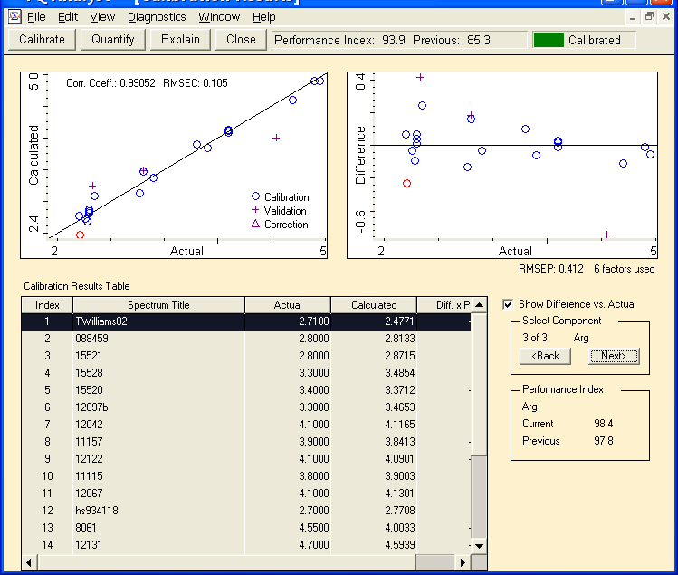

Fig. 18 C. Arginine Residue Calibration Results: Correlation Plot (The conditions are as stated in the caption of Figure 18A).

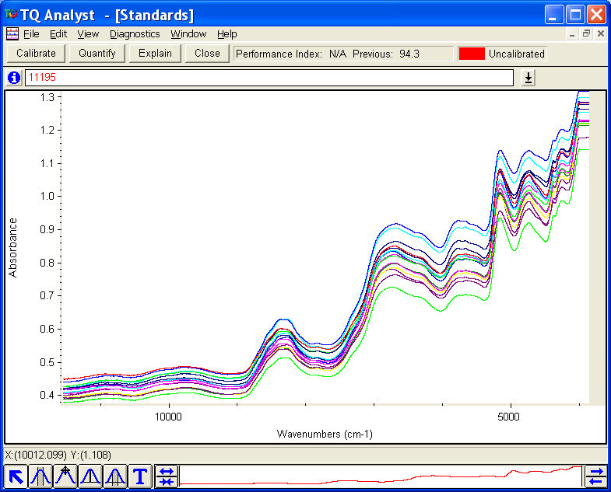

Fig.19A. Unprocessed FT-NIRS spectra of yellow coat, whole soybeans recorded as stated in the Fig.18 caption.

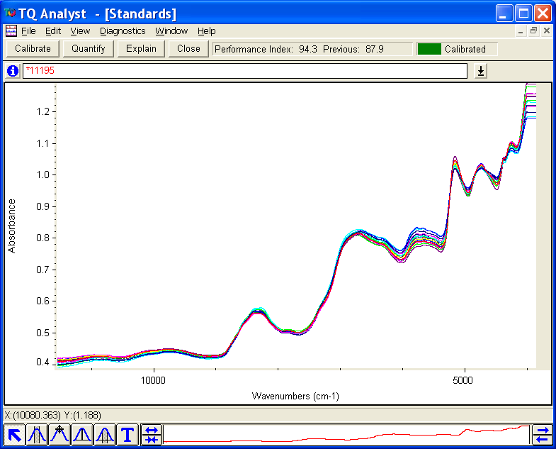

Fig.19B. MSC-corrected, processed FT-NIRS spectra of yellow coat, whole soybean standards for the new NIRS calibration that were recorded as stated in the caption of Fig.16A. (Note however that the spectral range is wider than in the actual calibration that utilized the FT-NIRS data points only in the spectral range from 4080 to 11500 cm⁻¹. As the MSC- corrected, NIRS data presented in this figure shows, the region most significant, and sensitive, to AA calibrations is located between 4080 and 8000 cm⁻¹ .

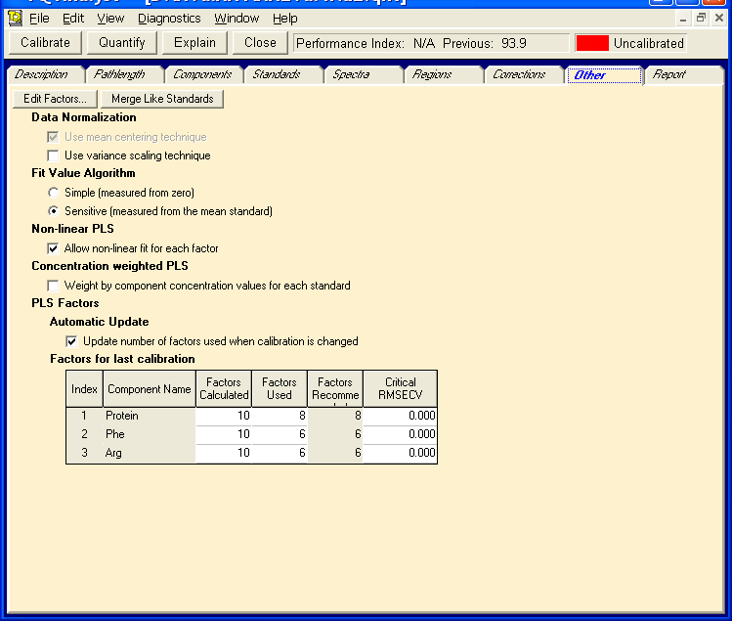

Fig. 20. Processing Conditions for the New Amino Acid Calibration in the TQ Analyst program.

Improving NIR calibrations, Summary:

  - Check the Correlation between amino acid and total protein content (dry)%
  - Select the amino acids for the NIR calibration following two criteria:
    - Correlation coefficient between a.a. and dry protein less than ~90% (R² < 0.81)
    - The widest available range of values in the calibration standard set (ROV > ~25%)
  - Primary measurement error for such amino acid composition measurements less than 5%.
  - Select a set of suitable calibration standards following the triangle matrix of amino acid triplet concentrations:
    - Phe-Leu- Lys (ROVs: 0.39; 0.21 ; 0.21 )

    - Phe-Lys- Ala ( ROV’s: 0.39 ;0.21 ;0.33)

    - Ser-Phe-Lys (ROVs: 0.30; 0.39; 0.21)

Summary of the Amino acid Results that I obtained:

- Total protein measurements done by wet chemistry analysis, for which a ~96% correlation with our lab’s NIR analysis has been confirmed.
- Several amino acid correlations with soybean protein content depend on the type of amino acid residue.
- There is significant potential for selecting the composition of amino acid residues present in soybeans, that is however limited to the subset that is not very highly correlated with the soybean protein content.

RESEARCH METHODS

- PROPOSED STUDIES

Although our current calibrations developed for the SpectrumOne NTS instrument and other transmission NIR instruments in our lab demonstrated the potential of these instruments, to fully make use of the potential and to further improve the accuracy, reliability, and robustness of our calibrations, the following studies are being carried out and they are proposed herein.
First we need to improve the reference values of bulk standard soybean samples by combining different reference methods; we also need to utilize several control samples and carry out measurements in quadruplicate. For protein analysis, in addition to the Kjeldahl method, the Lowry/Biuret method will be employed on our standard samples. Results of these three methods will be compared and combined to provide improved protein content of standard samples. For oil analysis, the organic solvent extraction method will be utilized and will be cross-checked with previous HPLC data. For all these methods, measurements will be made in triplicate for each standard soybean sample.
Since we need to carry out several measurements by reference methods on our standard samples and most of the above reference methods are destructive, such measurements will need to consume a large amount of samples of our standards. Some of our existing standards no longer have enough seeds for quadruplicate measurements by reference methods; a new set of standards with large quantity of samples were supplied by Prof. R.L. Nelson, the Curator of the USDA Soybean Germplasm Collection at UIUC. Improved reference values will be obtained for the new set of standard samples. Calibrations for bulk sample analysis on the SpectrumOne NTS will be improved and optimized with the new set of standard samples with more accurate reference values that have only become available when the set of preliminary data presented here was obtained. In addition, calibrations for bulk sample analysis will also be improved by employing the sample spinner to minimize effects of sample inhomogeneity.
Single whole-seed calibration on SpectrumOne NTS will also be improved and optimized with the new set of standard samples with improved reference values. The improved single seed calibration will be employed to carry out a study of composition variation in single soybean plants with well-defined genotypes. The variation of protein content among single plants have been analyzed and will be used in the calibrations for amino acid analysis. It is very important that one selects specific soybean varieties so that one obtains standard samples with a very wide range of total protein content soybeans, such as those shown in the new soybean protein and amino acid residue preliminary data presented in Figures 18 to 23.

- TECHNIQUES, INCLUDING FEASIBILITY OF THE TECHNIQUES

Near Infrared Spectroscopy for Soybean Composition Analysis
Near Infrared Spectroscopy (NIR) provides relatively simple and promising solutions for rapid, accurate, reliable and economical composition analysis of soybeans, despite the limitations caused by the broad bands that have been found to occur in solid samples of complex samples such as soybeans (Baianu, 1992). NIR is non-destructive and is routinely utilized for composition measurements. Furthermore, NIR Spectroscopy is much faster and much less expensive, compared to chemical analysis for large numbers of samples.
The principle of NIR spectroscopy is based on the concept that atom-to-atom bonds within molecules can vibrate and rotate at different energy levels. This energy level can be approximated by the following equation:

$$E\text{NIR}=E\text{rot}+E\text{vib}+E\text{anh}=j(j+1)\text{Bhc}+[1−x(n+1/2)]hν$$
Where:
$$\begin{aligned}\text{j: rotation quantum number: 0,1,2,3}\text{.}\text{.}\text{.} \\ \text{n: vibration quantum number: 0,1,2,3}\text{.}\text{.}\text{.} \\ \text{E }=\text{ energy eigenvalue; } \\ \text{x: anharmonic constant }≈0\text{.}\text{01}\end{aligned}$$
At room temperature and without any external NIR radiation, molecules vibrate and rotate at the lowest energy level (zero energy level) as is allowed by quantum mechanics (n = 0; j = 0). When exposed to NIR radiation, these molecules can absorb photons of light at a particular NIR frequency, and they are excited to a higher energy level. The transitions occur mainly between neighboring energy levels ($\text{ Δn}=±1$) and they are referred to as fundamental transitions. Absorptions generated by the fundamental transitions of most molecules are in the mid-IR and far-IR range (wavelength > 2500 nm). In addition to these fundamental transitions, molecules can also be excited by NIR irradiation from the zero energy level to energy levels beyond the first energy level ($\text{ Δn}=±\text{2,}±3\text{.}\text{.}\text{.}$), albeit with a lower probability. Such transitions are referred to as overtones. Absorptions that are due to overtones of chemical bonds with low reduced mass (such as O-H, N-H or C-H) occur in the NIR region (λ = 700 to 2500 nm). In addition to overtones, transitions of various chemical bonds can be coupled to generate a combination transition that is more difficult to quantify. Absorptions generated by combination transition of chemical bonds with a low reduced mass (O-H, N-H or C-H) also take place within the NIR region (Burns, et al, 2001; Raghavachari, 2001; Barton, 2002).
When a sample to be measured is exposed to the NIR radiation, the incident NIR beam can interact with the sample as a reflection, absorption, transmission, scattering, refraction and/or diffraction. Absorption is the most interesting phenomenon, as it is directly related to constituent concentration, as described by the Lambert-Beer Law:

A = ε * L * C
where:

A = True Absorbance
ε = Extinction coefficient of analyte
L = Path length
C = Concentration

The absorbance is usually not directly measured. It is however calculated indirectly from measurement of diffuse reflectance (A = Log 1/R), or from the transmittance (A = Log 1/T). The calculated absorbance is usually referred to as apparent absorbance and the apparent absorbance can be considerably affected by specular reflection and/or light scattering. Therefore, in order to obtain reliable NIR results, spectral pre-processing and other corrections are required.
After spectral pre-processing, the corrected apparent absorbance can be utilized for quantitation. For simple systems where the absorption band of the component to be analyzed is free of interference from other components in the sample, the absorbance at a single wavelength can be employed to calculate the individual component concentrations. For complex systems such as soybeans and grains, the NIR spectra are usually complex, since each absorption band usually contains contributions from several different components over most of the spectrum region. Therefore, one cannot simply use absorbance at a single wavelength to calculate the respective component concentrations. In order to derive an accurate chemical composition of a sample from the NIR spectra, absorbance data at several different wavelengths are needed to calculate the concentration of each component. The extraction and selection of the relevant wavelength for quantitation can be very cumbersome and mathematical; statistical transformations are usually employed for this purpose. NIR quantitation is usually carried out according to a predefined mapping between chemical concentrations and the spectral data. Such a mapping is usually referred to as a calibration. Calibration development for routine and/or commercial NIR instruments is one of the most important and challenging tasks for composition analysis in the field of NIR spectroscopy. It usually begins with a sufficient set (min. of 50 to 100) of standard samples with known component concentrations. The spectra are collected and corrected for the standard samples, and calibration models are established by way of a series of mathematical and statistical calculations.
Since Karl Norris initiated the pioneering work of NIR Spectroscopy on moisture analysis of wheat in the early 1960s, NIR Spectroscopy has evolved and developed steadily and it is now widely applied in the agricultural, pharmaceutical, biomedical, chemical, material science and engineering fields. A wide range of grains and oilseeds have been analyzed using NIR techniques, with varying degrees of success. Early reports showed that NIR Spectroscopy can be employed to determine major components such as protein and oil (Williams, 1975), as well as for moisture measurements (Ben-Gera and Norris, 1968) of soybeans, although with relatively large errors in both cases. Currently, NIR Spectroscopy has been widely utilized in protein and moisture analysis of wheat (Osborne, 2000); it has also been used in extractable starch analysis of corn (Paulsen, et al, 2000). There are very few reports on the current progress of NIR Spectroscopic analysis on soybeans, partly because most of the calibrations for soybean analysis were proprietary. Such proprietary calibrations are sometimes provided by the NIR instrument manufacturers for their instruments, and are sometimes not. There are a few commercial NIR Spectroscopic instruments with calibrations for protein, oil and moisture measurements of oil seeds. However, such calibrations were usually developed with only commercially available standard samples that have relatively narrow ranges of protein, oil and moisture contents. The predictions of subsequent samples using such calibrations are likely to be unreliable if they are employed to measure samples with protein or oil contents outside the narrow range of the standard samples used for the initial calibration. Consequently, such commercial calibrations can only be trusted for commercial oil seeds sample measurements and they have limited use for soybean breeding and genetic selection experiments, especially for high protein and oil soybean cultivars development, where the protein and oil contents of the developmental soybean samples have a very wide range. Even for samples that have component concentrations within the calibration range, the prediction accuracy and reliability are still lacking need further improvements. Furthermore, has have been only one published NIR work on individual amino acid composition (Kovalenko, et al., 2006), and no published NIR works on fatty acid composition and isoflavone analysis of soybeans, although related work on other agricultural products have been attempted, such as the NIR analysis of fatty acids on brassicas (Pallot, et al, 1999), and beef (Windham, et al, 1998). The importance of isoflavone analysis has been realized and efforts have been attempted on UV analysis (Lacombe, et al, 2001), but no work for isoflavone analysis has been done using NIRS yet. In order to improve the accuracy and reliability of analysis of major components in soybean, as well as to employ NIR for analysis of even low-level components such as amino acids, fatty acids and/or isoflavones, major advancements in both instrumentation and data analysis/calibration methodologies are needed.
Over the past few years, considerable improvements in spectral acquisition speed and stability over conventional NIR instruments have been achieved by utilizing the Diode Array NIR detectors, such as the DA-7000 NIR (DA-NIR) instruments manufactured by Perten Instruments, Inc. (Springfield, IL. http://www.perten.com), or the MCS-511 manufactured by Carl Zeiss / Atech, Inc (New York, NY, http://www.spectro.org/nir.htm). With the Diode Array detectors, the spectral data at different wavelengths can be collected simultaneously. Diode-Array-based NIR instruments have significantly improved speed and stability over conventional dispersive instruments. Besides the innovations of Diode Array instrument techniques, significant improvements on NIR instrument performance have also been achieved through the utilization of Fourier Transform (FT) techniques. There are currently only a very few FT-NIR instruments available commercially, such as the SpectrumOne NTS manufactured by the Perkin-Elmer Inc. (Wellesley, MA, www.perkinelmer.com), the ANTARIS and NEXUS series manufactured by the Thermo Nicolet Instruments Co. (Madison, WI, www.thermonicolet.com), or the VECTORS series manufactured by the Bruker Optics Inc. (Madison, WI, www.bruker.com). With such FT-NIR instruments, the spectral acquisition speed and resolution are significantly improved over conventional dispersive NIR instruments (Smith, 1979; Diem, 1993; You, T., 2006).
These novel instruments provide the potential of improving accuracy and reliability of NIR soybean spectroscopic analysis for major components such as protein and oil. They also provide the potential of employing NIR analysis for low-level components such as amino acids, fatty acids and isoflavones. In order to facilitate breeding and genetic selection for high-protein and high-yield soybean cultivars for agricultural, economic and human health food applications, the novel DA-NIR instruments and FT-NIR instruments will be evaluated and employed for rapid, accurate and reliable soybean composition analysis for both major components such as protein, oil and moisture, and low-level components such as amino acids, fatty acids and isoflavones. In order to take full advantage of such novel instruments and to improve the accuracy and reliability, NIR spectral pre-processing and data analysis/calibration methodology will also be improved in this research. Calibration developed on such novel NIR instruments are validated with measurements of large sets of soybean samples generated from breeding and genetic selection experiments. Through measurements of large sets of samples, an extensive database is also being generated for soybean NIR spectral and composition in terms of: protein, oil, individual amino acids, fatty acids and isoflavones (You, T, 2006). In the future, this research could help encourage breeders and geneticists to develop improved commercial soybean crops.

Evaluation and Selection of the NIR Spectroscopic Instruments
In this proposed research, rapid, accurate, reliable and economical soybean composition analysis methods will be developed with the state-of-the-art NIR instruments. There are currently a large number of NIR instruments commercially available. NIR instruments can be categorized in several ways, such as by the optical property measured, optical configurations, detector type, scan rate, and so forth (Workman, et al, 2001). The most common approaches to categorize NIR instruments are by the optical property measured and optical configurations. Based on the optical property measured, NIR instruments can be categorized as transmittance or reflectance instruments. Based on their optical configurations, NIR instruments can be categorized as instruments with Interference filters, Moving diffraction gratings, Fixed grating, Acousto-optical tunable filters (AOTF), Diode Array (DA-NIR), and Interferometers (FT-NIR). Interference filters-based NIR instruments are probably the most economical ones. The number and position of filters are designed and optimized for a specific type of sample, and it is generally not easy to expand such instruments to other sample types. Interference filters-based NIR instruments work mostly in transmission mode, such as the ZX800 and ZX50 instruments, manufactured by Zeltex Inc. (Hagerstown, MD, http:// www.zeltex.com). The ZX800 instrument is a bench scale instrument, whereas the ZX50 is a portable instrument. Both the ZX800 and the ZX50 utilize a series of filters to collect optical data at several pre-selected wavelengths. The ZX800 instrument has 12 filters at wavelengths between 918 nm and 1045 nm, and the ZX50 has 14 filters at wavelengths in the 893 nm to 1045 nm region. Although the ZX50 spectrometer has two more filters than the ZX800, the ZX800 has a superior optical and sampling design, and also has temperature stabilization, resulting in its superior reproducibility. The ZX800 instrument requires 80 to 100 grams of sample, whereas the ZX50 instrument is more flexible on sample size and can measure samples of as much as 100 grams, but also down to as little as 15 grams, which is important when only a limited amount of sample is available for analysis. Both instruments were provided with calibrations by the manufacturer for commercial soybean samples for protein, oil and moisture measurements. The major disadvantages of these two transmission instruments are that they collect spectra at only a few pre-selected wavelengths, because they were only designed specifically for major component analysis of bulk grains and oilseeds samples. For minor components, such as isoflavone analysis and low content amino acid residues, more flexible and powerful NIR instruments --such as Fourier Transform NIR (FT-NIR) spectrometers-- are required.
The application of Fourier Transform technology in NIR instrument design contributes to the instrument’s novelty and utility with much improved speed and stability. FT-NIR instruments are based on the use of a Michaelson interferometer to acquire an interferogram, which is a record of the intensity of radiation passing through the interferometer as one of the interferometer mirrors is moved at a constant speed. NIR spectrum is generated from the interferogram through a Fourier transform. There are currently several FT-NIR instrument providers, such as the Perkin-Elmer (www.perkinelmer.com) Bruker (www.bruker.com) and ThermoNicolet (www.nicolet.com). One of the best FT-NIR instruments currently available is the SpectrumOne NTS manufactured by Perkin-Elmer. The SpectrumOne NTS was designed with a modular sampling system. The default sampling module is transmission IR spectra collection with a DTGS detector, and the default sampling module can be easily replaced with an integrating sphere accessory, which includes an InGaAs detector to collect the reflectance spectrum in the NIR region (14,000 to 3,900 cm-1). The SpectrumOne NTS has very good sensitivity and reproducibility. It also includes a unique feature, the Absolute Virtual Instrument (AVI), which is able to standardize data throughout the lifetime of the instrument to a traceable, proven standard (You, T, 2006). Therefore, variations of instrument response are automatically corrected and the stability and reproducibility of the instrument is significantly improved.
The SpectrumOne NTS instrument will be evaluated and employed for improving NIR analysis of soybean seed composition, specifically for selected triplets of essential amino acid contents. The SpectrumOne NTS can be set up to collect and store NIR spectra with a 1 cm⁻¹ (<0.3 nm) interval. The SpectrumOne NTS instrument has superior resolution and flexibility; it has been calibrated and optimized for determination of major components such as protein, oil and moisture, as well as for determination of low-level components such as amino and fatty acids, as well as isoflavones.

Selection of Soybean Standard Samples for Calibration Development and Reference Methods for Composition Analysis of Standard Samples

Because the development of a NIR calibration begins with the collection of a set of NIR spectra of samples with known compositions (“standard samples”), calibration standard samples first need to be carefully selected, and concentrations of interested components of the standard samples need to be determined with reliable and accurate reference methods. In order to improve the reliability and robustness of the calibrations, our main strategy for calibration is to select a set of soybean standard samples that have as wide a range as possible of protein, oil, moisture, amino acid, fatty acid and amino acid concentrations. It is common knowledge that varieties high in oil are low in protein. The oil content in soybeans is an excellent check that our methods are working and needs to be incorporated in our calibrations. Furthermore, the standard samples are to be selected to give an even distribution of concentrations over the entire concentration range in order to improve correlation and also to minimize prediction errors. Soybean standard samples for calibrations of the SpectrumOne NTS instrument are, therefore, selected from a large collection of different accessions, including different developmental lines and germplasm, which satisfy the above requirements. Currently there are approximately 100 standard soybean samples selected for protein, oil and moisture analysis. The protein content of the standard samples covers the range from 33% to 52% (wet basis) and the oil content of the standard sample samples covers the range from 12% to 22% (wet basis). Because soybeans are harvested then dried for safe storage, the moisture content of the selected samples was in a relatively narrow range (7% to 12%). In order to improve the reliability and robustness of our moisture calibration, a subset of standard samples were equilibrated with controlled humidity to produce low moisture and high moisture concentrations. After equilibration the moisture content of our standard samples now cover the range from 2% to 31%. In addition to the 100 standard samples for major component analysis, another set of ~50 standard soybean samples were also selected and analyzed for isoflavones calibration development (You, T, 2006). However, we have not selected any soybean varieties high in certain amino acids, nor have we submitted them to breeders or geneticists. This is a very time-consuming step and will be omitted from our research at this time.
Once the standard samples are selected, the compositions of such samples need to be accurately and reliably analyzed. Protein analysis can be performed by the Kjeldahl method or the Lowry/Biurent method. The Kjeldahl method is the most common method for protein analysis. The basic process involves first digestion of the sample to convert the organic nitrogen in protein to ammonium, the ammonium is determined through titration and the total organic nitrogen can then be calculated from the ammonium content. Protein content of the sample is then converted from the organic nitrogen content by multiplying an empirical constant. This method has been criticized extensively as it measures the nitrogen content instead of the protein content and protein is usually not the only component that contains nitrogen. An alternative approach is the Lowry/Biuret method, which is based on the observation that substances containing two or more peptide bonds, such as protein, can form a purple complex with copper salts in alkaline solutions. The concentration of protein can be determined by measuring the intensity of the purple complex. It is simple, rapid, inexpensive, and most importantly, it measures directly the protein and the result is not interfered by non-protein nitrogen containing substance, as is the Kjeldahl method. On the other hand, the Lowry/Biuret method measures sample in solutions, which means that proteins have to be extracted for measurement. NMR is another common method for protein analysis (Baianu, 1993; Coles, 1980; Rutar et al, 1980; Wright et al, 1980). It does not require either digestion or extraction; solid samples can be directly measured with solid state NMR. The protein content can be determined by the carbonyl peak at ~172 ppm in a CPMAS ¹³C spectrum (Baianu, et al, 1993).
Oil analysis can be performed with organic solvent extraction. The oil content is determined by measuring the weight of the oil extracted from the sample. The AOCS (American Oil Chemists Society) standard method for oil analysis recommends the extraction is carried out in a Soxhlet extractor. The organic solvent can be petroleum either or hexane. The organic solvent extraction method for oil analysis is simple, but it is slow. It takes at least 24 hours continuous extraction to get reliable results. The oil analysis can also be carried out with high resolution ¹H NMR (Klempir, 1998) or the pulsed NMR.
Moisture analysis is mainly carried out by drying the sample under specified conditions and moisture content is determined from the loss of weight after drying. The drying conditions such as the time and temperature of drying can significantly affect the results, and they are specified in detail by the AOCS standard method.
The standard method for fatty acid analysis is to extract the oil from soybean seeds and then individual fatty acids are separated and detected by Gas Chromatography (GC). The standard primary method for amino acid determination is currently a similar GC-MS. We hope to be able to check these values against our NIR data to verify accuracy of our secondary NIR analysis method.
For this proposed research, the protein content of the standard samples is determined by the Kjeldahl method; the oil content is determined by the hexane extraction method.
For the selection of the individual amino acids to be analyzed, I will be using the following matrix, using pure amino acid powders:

#1: Pro-Glu-Ile
#2: Phe-Ser-Leu
#3: Lys-Cys-Phe

The proposed experiment will examine the performance of the NIR instrument on artificial combinations of amino acid powders, mixed together in the percentages listed in Figure 7. The experiment will be set up to analyze each set of simulated amino acid samples listed above in a combination matrix.
Fig. 24. Design of the Computer Simulation Study of PLS-1 Algorithm with three Components. Component Spectra. Adapted from T. You, PhD Thesis, 2006.
.
Fig. 25. Design of the Computer Simulation Study of PLS-1 Algorithm with three Components. Concentrations of Components, in percentages. [Adapted from T. You, PhD Thesis, 2006].

NIRS Calibrations for Selected AA Groups
- It is very important that there are enough knowns in the protein spectra to solve for all of the amino acid residues selected
- This research project will be using four groups of amino acid triplets such as:
  - Phe—Lys—Leu
  - Phe--Ala—Ileu

Planned work:
- Individual AA calibrations in amino acid mixtures (may also serve pharmaceutical purposes)
- FT-NIR spectra of AA’s in solution, including Trp
- FT-IR spectra of solid powder from 0 to 100% powder, using >100 samples for each trial
- Compare my Proline data to the NMR data
- Supplements: protein powders calibration
- Certain pharmaceutical drugs
- Revise the primary analysis chemistry tables with more accurate data.
Planned work also includes:
  - Crystalline amino acids powders vs. amino acids in gels
  - Egg white vs. egg albumin data
  - The making of concentrated solutions, followed by partial drying resulting in an amorphous gel rather than crystalline powders.

Model system rationale:
- Why do we need a model system? Why can’t we skip this step and just run our soybean samples?
  - We need knowledge of the bands assigned from the model systems (e.g., Tyrosine ring, Amide II band)
  - Serves to show the scale of the level of errors we can expect to get
  - Others have been unsuccessful

Timeline and steps:
- Select the best primary method for analyzing protein and amino acids
  - GCMS, NMR
  - Both are useable and comparable
  - NMR is superior
    - No acid hydrolysis
    - Readily available
- Obtain dry protein and moisture contents
- Obtain PLS-1 for protein content
- Check and validate NIR calibration for:
  - Amino acids using model systems of known and simple composition (e.g., mixtures of 3 amino acids), and
  - Proteins of known composition
    - i.e., “Model Systems”
- In principle, all amino acid combinations should be performed, but we will do 4 triplets
- TIME FACTOR: Running the samples
  - 4 x 100 samples x 2 (duplicates) = 800 samples
  - 5 minutes/sample…. 4,000 minutes
  - Or one month
- TIME FACTOR: Making the samples
  - 1 week per sample, parallel processing
  - Total estimated time: six months

NIR Spectra Pre-processing

For NIR quantitation, Lambert-Beer’s law requires the absorbance to be measured. Most NIR instruments, however, cannot measure the absorbance directly; they measure the reflectance or the transmittance instead. The measured reflectance or transmittance is converted to apparent absorbance. The apparent absorbance can be affected significantly by specular reflection and light scattering. In order to improve accuracy and reliability of NIR calibration, the NIR spectra data have to be corrected for specular reflection and light scattering effects. It has been reported that light scattering and baseline shifts may introduce more spectral variations than does the variations of constituent contents (Williams et al, 1987). Since a calibration is the mapping between the spectral data and the constituent contents, the regression and calculations involved in the calibration development will be dominated by light scattering and specular reflection effects, instead of constituent content variations, if light scattering and specular reflection effects are not corrected first. As a result, the calibration obtained without spectral preprocessing will be inaccurate and unreliable. Therefore, specular reflection and light scattering effects will be corrected first in this research.
The specular reflection effects appear to be a nonlinear baseline shift in both NIR and mid-IR spectra. The NIR spectrum of pure soybean powder was collected with a Perkin-Elmer SpectrumOne NTS spectrometer in diffuse reflectance mode with an integrating sphere accessory. It is clear that the baseline of the spectrum of soybean powder gradually shifts up from the high wavenumber end (close to the visible region) to the low wavenumber end (close to the mid-IR region). In order to reduce the specular reflection, the soybean powder was mixed with KBr powder. Spectra of two mixtures (6% soybean powder and 1% soybean powder, respectively) were collected and plotted in the same graph as the pure soybean powder spectra. The baseline shift effect was reduced by decreasing the percentage of soybean powder in the mixture. For the spectrum of the mixture of 1% soybean powder, the baseline shift effect caused by specular reflection becomes much smaller than that of the pure soybean powder. Similar effects of specular reflection have also been observed in the Mid-IR region (PerkinElmer, 2000).
The NIR spectra of soybeans need to baseline corrections for specular reflection effects. The difficulty of baseline correction remains, however. It is still unknown how the baseline is affected by specular reflection. For this research, an empirical, interactive baseline correction approach will be attempted. There exists such an interactive baseline correction method with the Perkin-Elmer “Spectrum” software. The baseline is corrected by subtracting from the raw spectrum a spline curve defined by a set of points in the wavenumber axis.
NIR spectra baseline shift can also be caused by instrument electronic noise or detector response variations. In such cases, the baseline variation can appear to be a constant over the entire spectra range, or a linear increase with the wavelength. Derivatives of NIR spectra can be employed effectively for both cases of baseline variations. For the first case, the first order derivative is effective as the effects of any constant are removed when taking first order derivatives of a function. For the second case, the second order derivative is effective as the effects of any linear function are eliminated when taking a second order derivative of a function. The derivatives of a spectrum can be calculated by a finite difference method, which is just the difference of spectral values between two adjacent points. It is relatively easy and simple to calculate, but the signal-to-noise ratio in the derivative spectrum is decreased. To solve this problem, Savitzky and Golay (Williams,1987) proposed an improved algorithm for derivative calculations, which begins with a least-squares linear regression of a polynomial of degree k over at least (k+1) data points. The derivatives of the spectrum can then be calculated as the derivatives of the fitted polynomial at each point. The Savitzky-Golay algorithm has been proven to be very useful since the signal-to-noise ratio is preserved in the calculated derivatives spectrum. The Savitzky-Golay derivatives will be employed for spectra pre-processing in this research.
In addition to the baseline shift effects caused by specular reflection, another important source of spectra variation is caused by light scattering. According to modern quantum electrodynamics theory (Feynman, 1963) as well as the Rayleigh theory of light scattering (Kortum, 1969), when a beam of light interacts with the molecules in a material, the incident light beam will be partially absorbed and partially scattered by such molecules. The absorbance is mainly affected by the concentrations of various components in the sample. Light scattering, on the other hand, is mainly caused by sample inhomogeneities, e.g., the difference of scattering coefficients between different parts of the same sample. The scattering coefficient is inversely proportional to the particle size of the sample, and it can also be affected by variations in the packing density from sample to sample (Mie, 1908; Thiessing, 1950). According to the Kubelka-Munk theory (Kortum, 1969), light scattering effects impact the apparent absorbance in a multiplicative manner. Therefore, they can not be corrected through linear correction algorithms. To correct for such multiplicative light scattering effects, Geladi (Geladi et al, 1985) proposed a semi-empirical approach called the Multiplicative Scattering Correction (MSC), which is currently one of the most commonly employed methods for NIR spectra preprocessing (Isaksson, 1990). It begins by calculating the average spectrum of the whole set of standard samples, and then attempts to determine the multiplicative parameter (scale factor) and the additive parameter (shift factor) for each spectrum through a linear regression of the spectral data against the mean spectrum. In some applications, the MSC approach was found to be very effective for correcting spectral variations caused by light scattering. NIR spectra of Soybean Protein Isolate (SPI) in H₂O solution were collected on the SpectrumOne NTS with an integrating sphere. The spectra were collected in transflection mode with the transflector. Before MSC pre-processing, the largest variation of absorbance is ~0.8 absorbance unit at ~5200 cm⁻¹. After MSC preprocessing, the spectral variation is reduced to less than 0.1 absorbance units. A PLS-1 calibration model was developed for a set of spectra, the number of factors for the PLS-1 model, the coefficient of determination (R2), and the standard error of cross validation (SECV) for protein, oil, and moisture analysis were determined for spectra before and after MSC pre-processing. Before light scattering correction, the PLS-1 calibration model needs 12 factors for protein, 8 factors for oil, and 12 factors for moisture; the coefficients of determination (R²) were 98.0%, 97.0%, and 95.0% for protein, oil, and moisture, respectively; the SECV values were 0.77, 0.49, and 0.60 for protein, oil, and moisture, respectively. After MSC pre-processing, the numbers of factors for the PLS-1 model were reduced to 7 for all three components; the R² values were increased to 99.5%, 98.9% and 98.8%; and the SECV values were reduced to 0.45, 0.30, and 0.23, for protein, oil, and moisture, respectively. With MSC preprocessing, the accuracy and reliability of the NIR analysis were improved significantly. Therefore, in order to develop accurate and reliable calibrations for soybean analysis, light scattering effects need to be corrected properly. Although the MSC method is effective for most of the application, in our research, we noted that it process the NIR spectra incorrectly when the calibration standards include high moisture samples. The reason is still not clear and it will be further investigated in this research.

NIR Calibration Algorithms and Software Tools
After careful selection of the standard samples and accurate measurements of the composition of the standard samples for reference values, NIR spectra can be collected for such standard samples with the state-oft-the-art NIR instruments. With proper spectra pre-processing to correct specular reflection and light scattering effects, the corrected NIR spectra of the standard samples need to be employed to develop a calibration to predict unknown samples. Calibrations are developed through regressions of the corrected NIR spectral data against the reference values of constituent concentrations. There are currently several different algorithms for the regressions. Among all the different algorithms for NIR calibration development, the most straightforward one is the Multiple Linear Regression (MLR), which correlates the concentration with a linear combination of absorbance values at a set of pre-selected wavelengths. This model can be applied very effectively for instruments that collect spectral data at only a small number of wavelengths, such as filter-based instruments. For the FT-NIR instrument, which collects spectral data for hundreds and thousands of different wavelengths, one usually can not apply the MLR model directly over the entire spectral range. From linear algebra, for a set of linear equations to have unique solution, the number of unknowns must not exceed the number of equations. Therefore, to apply the MLR model for calibration development, one need to satisfy the condition that the number of spectra or standard samples is larger than the number of spectral data points used for regression. For spectra that have hundreds and thousands data points, such as those collected with the SpectrumOne NTS, one needs to extract and select the most important and relevant data points for regression calculations, in order to utilize MLR. Manual extraction and selection of relevant spectral information can be tedious and unreliable. The alternative approach is to utilize more powerful statistical tools such as factor analysis.
Principal Component Regression (PCR) and the Partial Least Squares (PLS) are two of the most widely applied factor analysis methods for NIR calibration development. PLS and PCR can be applied for full spectra data and can generate reliable and robust NIR calibrations. The principle of PCR and PLS is based on the observation that although there are usually many different variations that make up a spectrum, including the variations of constituent concentrations between samples, inter-constituent interactions, instrument variations, difference in sample handling, etc., after proper data pretreatments such as the light scattering corrections, the largest variations in the calibration set would be due to the composition variations of the standard samples. The purpose of PCR and PLS is to calculate a set of variation spectra that can represent the variations due to composition variations. Such calculated variation spectra are also called loading spectra, principal components, or factors. The calculation of such spectra usually involves eigenvectors, and for this reason PCR and PLS algorithms are also called eigenvector methods. Once the factors are calculated, they are utilized instead of the raw spectra for building the calibration model, and the calibration can be optimized by optimizing the number of factors.
Although the concepts of PLS and PCR are similar, the approaches for calculating the factors (loading spectra) are different. The PCR algorithm calculates the factors independent of the concentration information whereas the PLS algorithm utilizes the concentration information of the calibration set to calculate the factors. As a result, the PLS factors contain more predictive ability for sample compositions than PCR and consequently the PLS method is usually more reliable than PCR. Besides the quantitative calculation of regression parameters for the calibration, the PLS algorithm can also provide some qualitative information for model validation, through the first-order loading spectrum, which is a first-order approximation to the pure-component spectrum (Haaland et al, 1988, Sorvaniemi et al, 1993). There are two different approaches to calculate the PLS factors for NIR calibrations of multiple components. The first approach is to calculate and optimize the PLS factors for each individual component and this approach is usually referred to as PLS-1. The second approach is to calculate and optimize the PLS factors for all the components simultaneously and this approach is referred to as PLS-2. PLS-2 involves fewer computations as it calculates only one set of factors for all the components. As a result, the PLS-2 algorithm performs faster than the PLS-1 algorithm. However, the calibration accuracy of PLS-1 is better than PLS-2 as the factors are optimized for each individual component. With the exponential increase of speed of computer chips, the amount of computations becomes less critical and PLS-1 is more extensively employed. PLS-1 algorithm will be employed for calibration development for the SpectrumOne NTS instrument in this research.
The computations of PLS and PCR are usually carried out with professional chemometrics software. There are currently several chemometrics software available for calibration development with PLS and PCR, such as: ThermoGalactic’s (Salem, NH, www.galactic.com) GRAMS/32 (Graphic Relation Array Management System), ThermoNicolet’s (Madison, WI, www.nicolet.com) TQ Analyst, Perkin-Elmer’s Quant+ (www.perkin-elmer.com), Bruker’s OPUS (www.bruker.com), etc. The GRAMS/32 software package is a professional spectroscopic software package and supports light scattering corrections as well as PLS and PCR regressions. The calibration results, including correlation plots, loading spectra, SECV plots, etc., can be exported to Microsoft Office products. It is extensible by allowing customer to write special programs in the Array Basic programming language. The TQ Analysis software package, on the other hand, provides some special features for FT-NIR instrument. It supports light scattering corrections, as well as spectral smoothing, and CLS, MLR, PCR, and PLS regressions. It is not as extensible as GRAMS/32 but it is specifically designed and optimized for FT-NIR instruments. In this study, both the GRAMS/32 and the TQ Analyst will be employed.
In order to check the performance of the software and improve the understanding of the PLS-1 algorithm, a computer simulation study was performed. In this computer simulation study, a pseudo type of sample is generated to have 3 simple components that have non-interfering absorption. Each component has a Gaussian absorption peak and the peak for each component is located at 900, 1200, and 1500 nm, respectively. Synthetic spectra data of this pseudo type of samples were calculated in Microsoft Excel by varying the concentrations of each component. The synthetic spectra data are then imported from Excel into GRAMS/32 to generate spectral files. A total of 21 spectra were generated and the concentrations of each component vary evenly from 0 to 100%. Calibrations based on PLS-1 model were calculated with both the GRAMS/32 and the TQ Analyst. The results from GRAMS/32 and the TQ Analyst are identical. For illustration, the results from the TQ Analyst were listed in Table II. From Table II, it is clear that the coefficients of determination are 1 for all three components, as expected. The SECV values for all three components are close to zero and the residuals (~ 10⁻⁶) are mainly introduced in the calculation in Excel as the Excel program does not have enough precision. From the computer simulation study, it is clear that both the GRAMS/32 and the TQ Analyst are reliable software tools for development of calibrations based on PLS-1 model. They also show that PLS-1 loading spectra provide very useful information that can be employed to validate calibrations.

Development and Validation of NIR Calibrations for Soybean Analysis on the SpectrumOne NTS Spectrometer Model

In this research, NIR calibrations have been developed and validated for single seed soybean analysis for the SpectrumOne NTS FT-NIR instrument. 50 standard samples were utilized to generate the calibration model and the rest 10 were utilized to calculate the Standard Error of Prediction (SEP). The protein content of the standard samples covers the range between 33% and 51% (wet); the oil content of the standard samples covers the range between 12% and 22% (wet); the moisture content of the standard samples covers the range between 7% and 12% (wet).
The SpectrumOne NTS FT-NIR instrument can be calibrated to accurate measure protein, oil, and moisture content of bulk soybean samples. In Table V, the correlation coefficients for all three components are above 99.3%; the values of SECV and SEP for all three components are below 1%. It shows that the SpectrumOne NTS instrument can also be calibrated to reliably measure protein, oil, and moisture content of individual soybean seeds.
For the SpectrumOne NTS, a preliminary calibration for soybean total isoflavones analysis was developed for half-seed soybean samples (You, T, 2006). The soybean seeds were cut in half first, the half seeds were then placed on top of the NIRA sapphire window with the flat surface downwards. NIR spectra were collected between 12,000 and 4,000 cm-1 with a digital interval of 1 cm⁻¹ and 16 scans for 25 isoflavone standard samples. Spectra were then baseline corrected for specular reflection. Calibration for isoflavone analysis was developed with the TQ Analyst program and MSC pre-processing was carried out to minimize light scattering effects. The correlation coefficient for total isoflavones was 99.1%, the SECV and SEP values for total isoflavones are 0.02% and 0.01% respectively.
Our current calibrations that were developed for the SpectrumOne NTS instrument demonstrate the potential of this state-of-the-art FT-NIR instrument for rapid, accurate, and reliable protein, oil, and moisture analyses on bulk soybean samples. The results also demonstrate that this instrument can be also employed on single seed soybean samples for protein, oil, moisture, and total isoflavones analyses.

APPLICATIONS OF RESULTS and FUTURE DEVELOPMENTS
There are many possible benefits of my research, which cover several fields of study and research. The following is only a concise list:

- Improved protein quality for soybeans and other food systems
- Improved human ingestion of soy products, which may have positive health implications, including cholesterol lowering, reduced incidence of cancer or cardiovascular disease
- Improved food formulations involving soybeans
- Facilitation of future fatty acid calibrations and analysis (a similar method)
- Essential for soy selection studies, including classical genetics, breeding experiments and back-crossing
- The discovery of soybean varieties with higher 11s subunits, which have different amino acid composition. Higher levels of charged amino acids in soybean protein may have different properties. If the Isoelectric Point (PI) of a soy protein is changed, a soybean may be discovered and/or developed with its protein having a lower PI, and would precipitate at pH 6, which may be more desirable than one that precipitates at pH 3 to 4 for certain applications such as making tofu, because of firmer and more persistent gels.
- Development and Validation of NIR Calibrations for Soybean Analysis of individual amino acids, their content in 11s and 7s globulins (substrates) and their correlation to total protein content in soybeans
- Improvement in the detection and identification of cancer cells and tumors, increased ability by researchers to distinguish between mammalian cells and cancerous mammalian cells, since the NIR/IR resolution that is looking at amino acids is on the order of 5 microns, and some cancer cells are on the same order of size. Markers or tags could be created that are analyzed on their amino acid profiles or calibrations. Amino-acid specific imaging of mammalian cells in vivo.
Possible future studies:
  - NIR spectra of amino acids in solution, with and without salts
  - Calibrations with meat, milk and egg proteins, and with some protein powders; study several different SPIs
  - NIR analysis of polypeptides (e.g., polyG, polyA)
  - NIR analysis of lysozyme; more soluble than SPI; determine if the spectra are neater
  - NIR analysis of flavonoids
  - NIR analysis of antioxidants
  - Comparison of NIR to FT-NIR; FT-NIR is better at detecting double bonds, but it’s more expensive and difficult
  - NIR amino acid analysis of a growing soybean
  - NIR amino acids and polypeptides analysis of hydrosylates, including for baby formulas
  - Comparative analysis of proteins
    - Milk caseins, alpha and beta
    - Wheat gluten proteins
    - Egg albumins (high in –SH)
    - Brazil nut protein (high in Cys, -SH)
    - Corn protein
    - Soy protein
    - Myosin and actin
    - Silk protein (Gly-Ala-X)
    - Collagen (Pro-Gly-X, hPro-Gly-X)

  - Protein standards
    - Soybeans
      - Pro, Glu, Lys, Phe
    - Alpha and beta caseins
      - Pro, Phospho-serine, hydrophobic amino acids like Ala, Ile and Gly
    - Wheat gluten (30% hydrophobic amino acids)
      - Hi Proline
      - Glx, Asx
      - Ala, Val, Ile and Leu
    - Egg albumin and lysozyme
      - Cys, some Pro (<10%)
    - Alpha helix
      - Hi Glu
      - Some Asp and His
      - Gly
    - Myosin
      - Hydrophobic
      - Charged
      - Low Arg, Lys and His
      - Alpha helical and a hydrophobic tail
    - Brazil nut
      - Hi Cys (-SH)
    - Corn zeins (35-40% hydrophobic)
      - Lys
      - High Gln, Asn
      - Low Glu, Asp
      - Very low Trp, Tyr
    - Milk
      - Beta-lactoglobulin
      - Along with lysozyme, is antibacterial.

LIMITATIONS

A major limitation of any proposed NIRS calibration research is that NIR instruments need to be calibrated by reliable primary reference methods. Another such limitation is the presence of very highly correlated components as already discussed above with specific examples that I have found for amino acids residues in soybean proteins.
Although the advancements in instrumentation and data analysis and calibration methodology can significantly improve the speed, reliability and reproducibility of the NIR measurements, the accuracy of the NIR analysis may be limited by the primary, reference methods. Although studies will be carried out in this research to improve the reference values of standard samples, the accuracy of NIR analysis is still subject to the limitations of the primary reference methods. Furthermore, no one has to date accurately described or performed the experiments we are undergoing. Since it is a new area of research, there is uncertainty associated with our results, including the inability to find solid correlations of amino acid compositions with total protein, as well as the ability to create accurate and useful predictive equations and charts for amino acid determination by NIR.

- Amino Acids affected by acid hydrolysis of the protein:
  - Absence of Trp data. Trp is just an example of what hydrolysis does to amino acids. Corrections to hydrolysis is one of the limitations caused by hydrolysis
  - No data extrapolation to zero for IEC determinations of modified amino acids
  - High degrees of correlation of certain amino acid residues with Dry Protein
  - A very limited range of ROV’s makes it impossible to do the calculations for those amino acids where this happens.

Matrix effects:
- A major obstacle that exists in the comparison of NIRS calibration data for different types of samples with the same chemical/biochemical composition but in different form or phase is the so-called “matrix effect.”
- This “matrix effect” depends on the state in which the molecules are in: Solid, Liquid or Gel phases, and also on different: texture/morphology, particle size distribution, molecular alignments.
- Other related causes are: internal gaps, different interfaces, internal sample changes in refractive index, and so on.

NMR advantages

- rp data included
- in situ data acquisition

Derivatization HPLC advantages

- Derivatization prior to acid hydrolysis followed by HPLC eliminates the limitations caused by the protein treatment with acid.

REFERENCES

- AACC. 1995. Approved Methods of Analysis, 9th Ed. The American Association of Cereal Chemists. St. Paul, Minnesota.
- AOAC International.1995. Official Methods of Analysis, 16th ed., AOAC International,
Gaithersburg, Maryland.
- AOCS. 1998. Official Methods and Recommended Practices of the AOCS – 5th Ed. The American Oil Chemists’ Society. Champaign, Illinois.
- AOCS. 2002. Additions and Revisions to the Official Methods and Recommended Practices of the AOCS. AOCS Press. Champaign, IL. AK4-95.
- Augustine, M. and Baianu, I.C.1984. High-Resolution ¹³C NMR and Ion Exchange Chromatography Amino Acid Profiling of Corn and Soybean Protein Hydrolysates. FASEB Proceed. 1125.
- Augustine, M.E., Baianu, I.C. 1986. High-Resolution 13C Nuclear Magnetic Resonance Studies of Maize Proteins. J. Cereal Science. 4: 371-378.
- Baianu, I.C. and H. Förster.1980. Cross-Polarization, High-Field 13C NMR Techniques for Studying Physicochemical Properties of Wheat Grains and Wheat Proteins., J. Applied Biochemistry, 2: 347-355.
- Baianu, I.C.1981. Carbon-13 and Proton NMR Studies of Wheat Proteins in Solution. J. Sci. of Food & Agriculture, 32: 309-313.
- Baianu, I.C., et al.1990. Ch8. In “NMR Applications in Biopolymers”. Edited by J.W. Finley et al., Plenum Press, New York.
- Baianu, I.C. 1992. Ed. “Physical Chemistry of Food Processes. Vol. 1: Fundamental Aspects.” Van Nostrand Reinhold. New York.
- Baianu, I.C., Pessen, H., Kumosinski, T.F. 1993. Ed. “Physical Chemistry of Food Processes. Vol.2: Advanced Techniques, Structures, and Applications.” Van Nostrand Reinhold. New York.
- Baianu, I.C., You, T., Guo, J., Nelson, R. L. 2002. Calibration of Dual Diode Array and Fourier Transform Near Infrared Reflectance Spectrometers for Composition Analysis of Single Soybean Seeds in Genetic Selection, Cross-Breeding Experiments, Proceedings for the 9th Biennial Conference of the Cellular and Molecular Biology of the Soybean, August 11-14, 2002, 508.
- Baianu, I.C., Costescu, D., You, T. 2002. Novel Techniques for Microspectroscopy and Chemical Imaging Analysis of Soybean Seeds and Embryos, Proceedings for the 9th Biennial Conference of the Cellular and Molecular Biology of the Soybean, August 11-14, 2002, 509.
- Baianu, I.C., You T., Costescu, D.M., Lozano, P.R., Prisecaru, V. and Nelson, R.L. 2004a. Chapter 11 "High-Resolution Nuclear Magnetic Resonance and Near-Infrared Determination of Soybean Oil, Protein and Amino Acid Residues in Soybean Seeds", Luthria, D. Ed., Oil Extraction and Analysis—Critical Issues and Comparative Studies, AOCS Press. Champaign, IL. p193-240.
- Baianu, I.C., You T., Costescu, D.M., Lozano, P.R., Prisecaru, V. and Nelson, R.L. 2004b. Chapter 12 "Near-Infrared Microspectroscopy, Fluorescence Microspectroscopy, Infrared Chemical Imaging and High-Resolution Nuclear Magnetic Resonance Analysis of Soybean Seeds, Somatic Embryos and Single Cells, Luthria, D. Ed., Oil Extraction and Analysis—Critical Issues and Comparative Studies, AOCS Press. Champaign, IL. p241-273.
- Baianu, I.C., You, T, Guo, J, Klempir, J, 2003. Near Infrared and Nuclear Magnetic Resonance Spectroscopy Determination of Protein, Oil, Moisture and Sugar Contents In Soybean Cultivars, USDA-ARS National Programs, February, http://www.nps.ars.usda.gov/ publications/ publications.htm?SEQ_NO_115=103670.
- Baianu, I.C., Korban, S.S., Costescu, D., You, T., Lozano, P., Hofmann, N.E. 2004c. Fourier Transform Near Infrared Microspectroscopy, Infrared Chemical Imaging, High-Resolution Nuclear Magnetic Resonance and Fluorescence Microspectroscopy Detection of Single Cancer Cells and Single Viral Particles. Cern. Ext-2004-069.
- Baianu I.C., You T., Guo J., and Nelson R.L. 2002. Calibration of Dual Diode Array and Fourier Transform NIR Spectrometers for Composition Analysis of Single Soybean Seeds in Genetic Selection, Cross-Breeding Experiments. Proceedings for the 9th Biennial Conference of the Cellular and Molecular Biology of the Soybean, August 11-14, 508.
- Baianu I.C., You T., Guo J., and Nelson R.L. 2002. Proceedings for the 9th Biennial Conference of the Cellular and Molecular Biology of the Soybean (Soy 2002), Urbana, Illinois, August 11-14, P506.
- Baianu I.C., You T., Guo J., and Nelson R.L. 2002. Proceedings of the China and International Soy Conference and Exhibition 2002 (CISCE 2002), Beijing, China, November 6-9, 2002, 412-413.
- Baianu I.C., You T., Guo J., and Nelson R.L. 2002. Proceedings of the China and International Soy Conference and Exhibition 2002 (CISCE 2002), Beijing, China, November 6-9, 2002, 391-392.
- Baianu I.C., You T., Guo J., and Nelson R.L. 2002. Proceedings of the China and International Soy Conference and Exhibition 2002 (CISCE 2002), Beijing, China, November 6-9, 2002, 414-415.
- Baianu I.C., You T., Guo J., and Nelson R.L. 2002. Proceedings for the 9th Biennial Conference of the Cellular and Molecular Biology of the Soybean (Soy 2002), Urbana, Illinois, August 11-14, 2002, P505.
- Baianu I.C., You T., Guo J., and Nelson R.L. 2002. Proceedings for the 9th Biennial Conference of the Cellular and Molecular Biology of the Soybean (Soy 2002), Urbana, Illinois, August 11-14, 2002, 508.
- Bardet, M., Foray, M.F. Bourguinon, J., and Krajewski, P. 2001. Investigation of Seeds with High-Resolution Solid-State 13C NMR. Magnetic Resonance in Chemistry, 39: 733-738.
- Barton F.E. 2002. Theory and Principles of Near-Infrared Spectroscopy, Spectroscopy Europe, 14(1): 12-18.
- Belitz, H.D. and Grosch, W. 1987. Food Chemistry, Springer-Verlag, Berlin.
- Ben-Gera, I., Norris, K.H. 1968. Determination of Moisture Content in Soybeans by Direct Spectrophotometry. Isr. J. Agric. Res. 18: 125-132.
- Bardet, M., Foray, M.F., Bourguinon, J., and Krajewski, P. 2001. Investigation of Seeds with High-Resolution Solid-State 13C NMR. Magnetic Resonance in Chemistry, 39: 733-738.
- Birth, G. S. 1986. The Light Scattering Characteristics of Ground Grains. Intern. Agrophys. 2(1): 59-67.
- Brim, C.A. and Burton, J.W. 1979. Recurrent Selection in Soybeans (Glycine max): 2. Selection for Increased Percent Protein in Seeds. Crop Sci. 19(4): 494-498.
- Burton, J.W., Wilson, R.F., Brim, C.A., and Rinne, R.W. 1989. Registration of Soybean Germplasm Line with Modified Fatty Acid Composition of Seed oil. Crop Sci. 29: 1583.
- Burton, J.W., and Wilson, R.F.1994. Registration of N88-480, a Soybean Germplasm Line with High Concentration of Oil in Seeds. Crop Sci. 34: 313-314.
- Buning, P.H. and Diller, M. 2000. Rapid Analysis of Foods Using Near-Infrared Spectrometry (NIRS): Development, Use and New Possibilities. Ernahrungs Umschau. 47(1): 15-20.
- Buslov, D.K., Nikonenko, N.A., 1997. Regularized Method of Spectral Curve Deconvolution. Applied Spectroscopy, 51(5): 666-672.
- Buslov, D.K., Nikonenko, N.A., Sushko, N.I. and Zhbankov, R.G. 1999A. Analysis of the Results of α-D-glucose Fourier Transform Infrared Spectrum Deconvolution: Comparison with Experimental and Theoretical Data. Spectrochimica Acta Part A. 55: 229-238.
- Buslov, D.K., Nikonenko, N.A., Sushko, N.I. and Zhbankov, R.G. 1999B. Deconvolution of Fourier Transform Infrared Spectrum of α-D-Galactose: Comparison with Experimental and Theoretical Data. Spectrochimica Acta Part A. 55: 1101-1108.
- Cameron, A.G. 1967. An Assessment of the Potential Application of the Method of Attenuated Total Reflectance (ATR) Infrared Qualitative Analysis to Food Materials. J. Food Technology. 2:223.
- Carrao, P.M., de-Goes, F.S. and Kikuchi, A. 2002. Extraction Time for Soybean Isoflavone Determination. Brazilian Archives Bio. Technol. 45 (4): 515-518.
- Carr, H.Y., and Purcell, E.M. 1954. Effects on Diffusion on Free Precession in Nuclear Magnetic Resonance Experiments. Physical Review, 94 (3): 630-638.
- Cinier, R., Cuilment, J. 1998. PLS Calibration for Precise and Practical Quantitative Analysis of Simple Solutions Using NIR Spectroscopy. Bruker Report, 146:6-9.
- Coblentz, W.K. 1982. A Study in the Near Infrared Reflectance Spectra of Proteins and Related Compounds. MS thesis. Pennsylvania State University.
- Costescu, D.M. 2003. MS Thesis, University of Illinois at Urbana-Champaign, Urbana, Illinois.
- Delwiche, S.R., 1995. Single Wheat Kernel Analysis by Near-Infrared Transmittance: Protein Content. Cereal Chem. 72: 11-16.
- Derome, A.E. 1987. Modern NMR Techniques for Chemistry Research, p. 129, Pergamon Press, New York.
- Dev, S.B., Rha, C.K. and Walder, F. 1984. Secondary Structural Changes in Globular Protein Induced by a Surfactant: Fourier Self-Deconvolution of FT-IR Spectra. J. Biomolecular Structure & Dynamics. 2(2): 431-442.
- Diaspro, A., and Robello, M. 1999. Multi-Photon Excitation Microscopy to Study Biosystems. European Microscopy and Analysis, 5: 5-7.
- Diem, M. 1993. Ed. Introduciton to Moden Vibrational Spectroscopy. John Wiley & Sons. New York, NY.
- Doty, D. M., Bergdoll, M. S., Nash, 1-I. A., and Brunson, A. M. 1946. Cereal Chem. 23:199.
- Eigen, M. and Rigler, R.1994. Proc Natl. Acad. Sci. USA. 91: 5740.
- Fahrenfort, J. 1961. Attenuated Total Reflection. A New Principle for the Production of Useful Infrared Reflection Spectra of Organic Compounds. Spectrochim. Acta 17: 698
- Feynman, R.P. 1963. “Lectures on Physics”, Vol3, Addison-Wesley Publishing Company, Reading, MA.
- Fraenkel-Conrat, H, Cooper, M., 1944. The Use of Dyes for the Determination of Acid and Basic Groups in Proteins, J. Biol. Chem., 154: 239-246.
- Galactic Industries Corporation. 1996. GRAMS/32 User’s Guide: PLS plus/IQ for GRAMS/32 and GRAMS/386, Chapters 1-4.
- Geladi, P., MacDougall, D., Martens, H. 1985. Linearization and Scatter-Correction for Near- Infrared Reflectance Spectra of Meat. Applied Spectroscopy. 39(3): 491-500.
- Goldflus, F., Ceccantini, M., and Santos, W. Amino Acid Content of Soybean Samples Collected In Different Brazilian States: Harvest 2003/2004. Rev. Bras. Cienc. Avic. [Online]. 2006, 8(2): 105-111.
- Guo, J., You T., Baianu, I.C., Nelson, R.L. 2002. Evaluation of Four Dispersive NIR Instruments and Methodology Development for Soybean Composition Analysis in Genetic Selection and Breeding Programs, Proceedings of the China and International Soy Conference and Exhibition 2002 (CISCE 2002), November 6-9, 2002, 412-413.
- Guo, J. 2004. Development of Dispersive and Fourier Transform Near Infrared Spectroscopy Methodology for Food and Edible Seed Analysis. PhD Thesis, University of Illinois at Urbana-Champaign, Urbana, Illinois.
- Guo, J., Baianu, I.C. 2002. Determination of Soy and Other Health Foods Composition by Fourier Transform Near Infrared Reflectance Spectroscopy, Proceedings for the 9th Biennial Conference of the Cellular and Molecular Biology of the Soybean, August 11-14, P506.
- Guo J, You, T., Baianu I.C., and Nelson R.L., 2002. Evaluation of Four Dispersive NIR Instruments and Methodology Development for Soybean Composition Analysis in Genetic Selection and Breeding Programs. Proceedings of the China and International Soy Conference and Exhibition (CISCE), November 6-9, 412-413.
- Guo J., and Baianu I.C. 2002. Rapid Determinations of Soybean Isoflavones, Soy and Other Health Foods Composition by Fourier Transform Near Infrared Reflectance Spectroscopy. Proceedings of the China and International Soy Conference and Exhibition (CISCE), November 6-9, 391-392.
- Klempir J. M. 1999. Nuclear Magnetic Resonance Characterization of Soybeans for Oil Content Measurement. MS Thesis, University of Illinois at Urbana-Champaign, Urbana, Illinois.
- Haaland, D.M., Thomas, E.V. 1988. Partial Least-Squares Methods for Spectral Analyses. Relation to Other Quantitative Calibration Methods and the Extraction of Qualitative Information. Analytical Chemistry, 60: 1193-1202.
- Hammond, E.G., and Fehr, W.R. 1982. Progress in Breeding for Soybean Oil with Low Linolenic Acid. J. Am. Oil Chem. Soc. 59 (4): 304A.
- Hammond, E.G., and Fehr, W.R. 1983. Registration of A6 Germplasm Line of Soybean. Crop Sci. 23: 192-193.
- Harrick, N. J. 1960. Surface Chemistry from Spectral Analysis of Totally Internal Reflected Radiation. J. Phys. Chem. 64:1110.
- Haswell, S.J. 1992. Practical Guide to Chemometrics. Marcel Dekker, Inc., New York.
- Harris, Robin K. 1983. Nuclear Magnetic Resonance spectroscopy, A Physicochemical View, Pitman, London.
- Helms, T., Orf, J., Vallad, G., McClean, P. 1997. Genetic variance, coefficient of parentage, and genetic distance of six soybean populations. Theor Appl Genet, 94:20-26
- Howard Mark. 2001. Near-Infrared Applications in Biotechnology, (Biochemical and Pharmaceutical). Chapter 11 “Fundamentals of Near-Infrared Spectroscopy”, P. 312, Edited by Raghavachari, R. Promega Corporation, Madison, Wisconsin.
- Hymowitz, T., Collins, F.I., Panczner, J. and Walker, W.M. 1972. Relationship between the Content of Oil, Protein, and Sugar in Soybean Seed. Agron. J. 64: 613-616.
- Isaksson, T., Miller, C.E. and Naes, T. 1992. Nondestructive NIR and NIT Determination of Protein, Fat and Water in Plastic Wrapped, Homogenized Meats. Applied Spectroscopy. 46: 1685.
- Isaksson, T., Naes, T. 1988. The Effect of Multiplicative Scatter Correction (MSC) and Linearity Improvement in NIR Spectroscopy. Applied Spectroscopy. 42(7): 1273-1284.
- Jones, D.B. 1931. Factors for Converting Percentages of Nitrogen in Foods and Feeds into Percentages of Nitrogen , USDA Circular No. 183, Washington DC.
- Joslyn, M.A. 1970. Methods in Food Analysis, 2nd ed. Academic Press, New York.
- Kabelka, E.A., Diers, B.W., Fehr, W.R., LeRoy, A.R., Baianu, I.C., You, T., Neece, D. J., Nelson, R. L. 2004. Putative Alleles for Increased Yield from Soybean Plant Introductions. Crop Sci., 44:784-791.
- Kakalis, L.T. and Baianu, I.C. 1989. A High-Resolution 13C NMR Study of Glycinin in D2O Solutions. J. of Agric. & Food Chem. 37: 1222-1228.
- Kakalis, F.T. and Baianu, I.C. 1990. High-Resolution 13C NMR Study of the Soybean 7S Storage Protein Fraction in Solution. J. of Agric. & Food Chem. 38: 1314-1320.
- Kettling, U., Koltermann, A., Schwille, P., and Eigen, M. 1998. Real-Time Enzyme Kinetics Monitored by Dual-Color Fluorescence Cross-Correlation Spectroscopy. Proc. Natl. Acad. Sci. USA 95: 1416-1420.
- Klempir J. M. 1999. Nuclear Magnetic Resonance Characterization of Soybeans for Oil Content Measurement. MS Thesis, University of Illinois at Urbana-Champaign, Urbana, Illinois.
- Kortum, G. 1969. Reflectance Spectroscopy--Principles, Methods, Applications. Springer-Verlag, NewYork, NY.
- Kuiken, K.A., and Lyman, C.M. 1948. Essential amino acid composition of soy bean meals prepared from twenty strains of soy beans. J Biol. Chem. 6: 29-36.
- Lamb, D., Hurburgh, C.R. 1991. Moisture Determination in Single Soybean Seeds by Near-Infrared Transmittance. Trans. ASAE. 34: 2123-2129.
- Lee, S.J., Ahn, J.K., Kim, S.H., Kim, J.T., Han, S.J., Jung, M.Y. and Chung, I.M. 2003. Variation in Isoflavone of Soybean Cultivars with Location and Storage Duration. J. Agric. Food Chem. 51(11): 3382-3389.
- Liu, K.S. 1997. Soybeans: Chemistry, Technology, and Utilization. Chapman & Hall, New York, NY. 532p.
- Liu, K.S. 2000. Expanding Soybean Food Utilization. Food Technology. 54(7): 46-58.
- Lowry, O. H., N.J. Rosebrough, A. L. Farr and R. J. Randall, 1951. Protein Measurement with the Folin Phenol Reagent. J Biol. Chem. 193: 265-275.
- Madden, H.M., 1978. Comments on the Savitzky-Golay Convolution Method for Least-Squares Fit Smoothing and Differentiation of Digital Data. Anal. Chem. 50: 1383.
- Maluszynski, M., Ahloowalia, B.S. and Sigurbjornsson, B. 1995. Application of in vivo and in vitro Mutation Techniques for Crop Improvement. Euphytica, 85: 303-315.
- Mansur, L.M., Orf, J.H., Chase, K., Jarvik, T., Cregan, P.B. and Lark, K.G. 1996. Genetic Mapping of Agronomic Traits Using Recombinant Inbred Lines of Soybean. Crop Sci. 36: 1327-1336.
- Mark, H. 2001. Near-Infrared Applications in Biotechnology, Chapter 11 “Fundamentals of Near Infrared Spectroscopy”, p.312, Editor Raghavachari, R. Promega Corporation, Madison, Wisconsin.
- Martens, H., Jensen, S.A. and Geladi, P. 1983. Proceedings, Nordic Symposium on Applied Statistics, Stavanger, June 1983, pp.205-234.
- Mie, G. 1908. Ann. Physik. 4: 25, 377.
- Minson, D.J., Tuckett, P.G, Law D.P. 1985. A Comparison of three Methods of Increasing the Precision of Regression Used for Estimating Nutritive Value of Forages by Near Infrared Reflectance. 1985, NIR84 Proc. Int. Symp. Near Infrared Reflectance Spectroscopy., 1st. RACI, Cereal Chem. Div. Melbourne, Australia. pp 138-148.
- Myoung, G.C., In, Y.B., Sung, T.K., Won, Y.H., Doo, C.S., Huhn, P.M. and Kwang, H.K. 2001A. Determination of Protein and Oil Contents in Soybean Seed by Near Infrared Reflectance Spectroscopy. Korean J Crop Sci. 46(2): 106-111.
- Myoung, G.C., In, Y.B., Sung, T.K., Won, Y.H., Doo, C.S., Huhn, P.M. and Kwang, H.K. 2001B. Non-Destructive Method for Selection of Soybean Lines Contained High Protein and Oil by Near Infrared Reflectance Spectroscopy. Korean J Crop Sci, 46(5): 401-406.
- Nieh C.D. and Snyder, H.E. 1991. Solvent Extraction of Oil from Soybean Flour: I. Extraction Rate, a Countercurrent Extraction System, and Oil Quality. J. Am. Oil Chem. Soc. 68(4): 246-249.
- Nielsen, S.S. 1994. Introduction to the Chemical Analysis of Foods. Jones and Bartlet Publishers, Boston, London, Chapters 7, 10, 14.
- Norris, K.H. and Williams, P.C. 1984. Optimization of Mathematical Treatment of Raw Near-IR Signal in the Measurement of Protein in Hard Red Spring Wheat: 1. Influence of Particle Size. Cereal Chem. 62: 158-165.
- Norris, K.H. 1983. Using Gap Derivatives as Pre-processing for Quantitative Models, Food Research & Data Analysis, Proceedings of the 1982 IUFST Symposium, Martens, H. Ed., Applied Science Publishers, Oslo, 46-47.
- Ohnishi, S.T. and Barr, J.K.1978. A Simplified Method of Quantitating Protein Using the Biuret and Phenol Reagents. Anal. Biochem. 86: 193-200.
- Openshaw, S.J. and Hadley, H.H. 1984. Selection Indexes to Modify Protein Concentration of Soybean Seeds. Crop Sci. 24: 1-4.
- Orman, B.A., Schumann, R.A., 1992. Nondestructive Single-Kernel Oil Determination of Maize by Near-Infrared Transmission Spectroscopy. J.Am.Oil Chem. Soc. 69: 1036-1038.
- Osborne, B. G., Fearn, T. and Hindle, P.H. 1993. Practical NIR Spectroscopy with Applications in Food and Beverage Analysis, 2nd Edition. pp 13-21, 99-117. Longman Scientific & Technical, Harlow, UK. 227p.
- Pantheea D.R., Pantalonea V.R., Westa D.R., Saxton A.M., and Sams C.E., 2005. Quantitative Trait Loci for Seed Protein and Oil Concentration, and Seed Size in Soybean. Crop Sci, 45:2015-2022.
- Paulsen, M.R., Bajaj, M. 2000. Using Unscrambler for Extractable Corn Starch Calibration. ASAE Paper No. 00-3091. ASAE. St. Joseph, MI.
- Pazdernik D.L., Killam A.S. and Orf J.H. 1997. Analysis of Amino and Fatty Acid Composition in Soybean Seed, Using Near Infrared Reflectance Spectroscopy. Agron J 89:679-685.
- PerkinElmer Instruments, 2000. Spectrum One User’s Guide, Shelton, CT 06484, USA.
- PerkinElmer Instruments, 2002. AutoImage User’s Guide, Sheldon, CT 06484, USA.
- Peterson, G. L. 1979. Review of the Folin Phenol Protein Quantitation Method of Lowry, Rosebrough, Farr and Randall. Analytical Biochemistry 100: 201-220.
- Pfeffer, P. and Gerasimowicz, W. (Eds.). 1987. NMR in Agriculture. CRS Publishers, Boca Raton, FL.
- Pomeranz Y. and Meloan, C.E. 1994. Food Analysis Theory and Practice, 3rd edition, chapter 33, 567-574. Chapman & Hall, New York, NY.
- Qiao Y., van Kempen, T.A.T.G. 2004. Technical note: Comparison of Raman, mid, and near infrared spectroscopy for predicting the amino acid content in animal meals. J. Anim. Sci. 2004. 82:2596-2600.
- Raghavachari, R. 2001. Near-Infrared Applications in Biotechnology, Marcel-Dekker, New York, NY.
- Reffer, J.A., Martoglio, P.A. 1995. Uniting Microscopy and Spectroscopy, Practical Guide to Infrared Microspectroscopy, Chapter 2, p.41, Edited by Howard J. Humecki, Marcel Dekker, New York, NY.
- Rigler R. and Widengren J. 1990. Ultrasensitive Detection of Single Molecules by Fluorescence Correlation Spectroscopy, BioScience (Ed. Klinge & Owman) p.180.
- Rippe, K. 2000. Simultaneous Binding of Two DNA Duplexes to the NtrC-Enhancer Complex Studied by Two-Color Fluorescence Cross-Correlation Spectroscopy. Biochemistry 39(9): 2131-2139.
- Robertson, J. A. and F. E. Barton.1984. Oil and Water Analysis of Sunflower Seeds by Near Infrared Reflectance spectroscopy, JAOCS, 61 (3): 543-547.
- Robinson, H.W. and C.G. Hodgen 1940. The Biuret Reaction in the Determination of Serum Protein. 1. A Study of the Conditions Necessary for the Production of the Stable Color which Bears a Quantitative Relationship to the Protein Concentration. Journal of Biological Chemistry 135: 707-725.
- Rutar, V. 1982. A New Possibility for Nondestructive Protein Content Determination in Viable Seeds, Applied Spectroscopy, 36: 259-260.
- Rutar, V., M. Kovac and G. Lahajnar.1989. Nondestructive Study of Liquids in Single Seeds Using Nuclear Magnetic Resonance and Magic Angle Sample Spinning, JAOCS, 66: 961-965.
- Rutar, V. 1984. NMR Studies in Intact Seeds, in Nuclear Magnetic Resonance in Agriculture. editors Philip E. Pfeffer and Walter V. Gerasimowicz, CRC Press Inc., Boca Raton, Florida.
- Rutar, V.1989. Magic Angle Spinning NMR Spectroscopy of Liquids as Nondestructive Method for Studies of Plant Seeds, J. Agric. Food Chem., 37: 67-70.
- Savitsky, A. and Golay, M.J. 1964. Smoothing and Differentiation of Data by Simplified Least Squares Procedures. Anal. Chem. 36: 1627-1639.
- Schwille P., Oehlenschläger F. and Walter N. 1996. Analysis of RNA-DNA Hybridization Kinetics by Fluorescence Correlation Spectroscopy, Biochemistry 35: 10182.
- Schwille, P., Bieschke, J. and Oehlenschläger F. 1997. Kinetic Investigations by Fluorescence Correlation Spectroscopy: The Analytical and Diagnostic Potential of Diffusion Studies, Biophys. Chem. 66: 211-228.
- Schwille P., Meyer-Almes F.-J., and Rigler R. 1997. Dual-Color Fluorescence Cross-Correlation Spectroscopy for Multicomponent Diffusional Analysis in Solution, Biophys. J. 72: 1878-1886.
- Schwille, P., Haupts, U., Maiti, S., and Webb. W. 1999. Molecular Dynamics in Living Cells Observed by Fluorescence Correlation Spectroscopy with One- and Two-Photon Excitation. Biophysical Journal, 77(10):2251-2265.
- Schwille, P. 2001. Fluorescence Correlation Spectroscopy. Theory and applications. Rigler R., and Elson, E. S. eds. Springer Verlag: Berlin. p360.
- Shchegolikhin, A., Lazareva, O. 2000. Diffuse Reflectance for the Routine Analysis of Liquids and Solids. Internet Journal of Vibration Spectroscopy [www.ijvs.com]. 4(1): 8-38.
- Shadow, W. 1998. Rapid Analysis for the Food Industry Using Near-Infrared Spectroscopy. Perten Instruments North America, Inc. 17p.
- Shadow,W. and A. Carrasco. 2000. Practical Single-Kernel NIR/Visible Analysis for Small Grains. Cereal Foods World 45(1): 16-18.

- Silvela, L., Rodgers, R., Barrera, A., Alexander, D.E. 1989. Effect of Selection Intensity and Population Size on Percent Oil in Maize, Zea mays L. Theoretical and Applied Genetics 78: 298-304.
- Simpson, A.M. Jr. and Wilcox, J.R. 1983. Genetic and Phenotypic Associations of AgronomicCharacteristics in Four High Protein Soybean Populations [Glycine max]. Crop Sci. 23: 1077-1081.
- Smith, A.L. 1979. Ed. Applied Infrared Spectroscopy: Fundamentals, Techniques, and Analytical Problem-solving. John Wiley & Sons. New York, NY.
- Smith, P.K., Krohn, R.I., Hermanson, G.T., Mallia, A.K., Gartner, F.H., Provenzano, M.D., Fujimoto, E.K., Goeke, N.M., Olson, B.J., and Klenk, D.C. 1985. Measurement of Protein Using Bicinchoninic Acid. Anal. Biochem. 150: 76-85.
- Song, T., Barua, K., Buseman, G. and Murphy, P.A. 1998. Soy Isoflavone Analysis: Quality Control and a New Internal Standard. Am. J. Clinical Nutrition. 68(6), Supplement, 1474S-1479S.
- Sorvaniemi, J., Kinnunen, A., Tsados, A., Malkki, Y. 1993. Using Partial Least Squares Regression and Multiplicative Scatter Correction for FT-NIR Data Evaluation of Wheat Flours, Lebensmittel-Wissenschaft & Technologie, 26(3): 251-258.
- Specht, J., Nelson, R.L., Webster, R., Naidu, S., Ainsworth, E. and Ort, D. 2002. A Genomic Perspective on the Soybean Protein(+)/Oil(-)/Yield(-) Enigma. Program and Proceedings for the 9th Biennial Conference of the Cellular and Molecular Biology of the Soybean, August 11-14, 2002, P.202.
- Stuber, C.W. 1992, Biochemical and Molecular Markers in Plant Breeding. Plant Breeding Rev. 9: 37-61.
- Tajuddin, T., Watanabe, S., Masuda, R., Harada, K. and Kawano, S. 2002. Application of Near Infrared Transmittance Spectroscopy to the Estimation of Protein and Lipid Contents in Single Seeds of Soybean Recombinant Inbred Lines for Quantitative Trait Loci Analysis. J. Near Infrared Spectrosc. 10(4): 315-325.
- Tekel, J., Daeseleire, E., Heeremans, A. and Peteghem, C.V. 1999. Development of a Simple Method for the Determination of Genistein, Daidzein, Biochanin A, and Formononetin (Biochanin B) in Human Urine. J. Agric. Food Chem. 47(9): 3489-3494.
- Theissing, H. H. 1950. J. Opt. Soc. Am. 40: 232.
- Thompson, J.A. and Nelson, R.L.1998. Utilization of Diverse Germplasm for Improving Soybean Yield. Crop Sci. 38: 1362-1368.
- Thompson N.L. 1991. In Topics of Fluorescence Spectroscopy. Lakowicz, J.R. ed. Plenum Press, Vol 1 p 337.
- Tiwari, P. N. and Gambhir, P. N.1995. Seed Oil Determination without Weighing and Drying the Seeds by Combined Free Induction Decay and Spin-Echo Nuclear Magnetic Resonance Signals, JAOCS, 72(9).
- USDA National Agriculture Statistcal Service (NASS). 1999. USDA-NASS Agricultural Statistics 1999. http://www.usda.gov/nass/pubs/agr99/acro99.htm.
- Van K., HWANG E.-Y., KIM, M.Y., PARK H.J., LEE S.-H., and Cregan P.B. 2005. Discovery of SNPs in Soybean Genotypes Frequently Used as the Parents of Mapping Populations in the United States and Korea. Journal of Heredity, 96(5):529–535.
- Velasco, L., Goffman, F.D., and Becker H.C. 1999. Development of Calibration Equations to Predict Oil Content and Fatty Acid Composition in Brassicaceae Germplasm by Near Infrared Reflectance Spectroscopy. JAOCS, 76: 25-30.
- Verma, D.P.S., Shoemaker, R.C. 1996. Soybean Genetics, Molecular Biology and Biotechnology. Cab International. Guildford, UK.
- Watson et al. 1987. Ed. Corn: Chemistry and Technology. American Assosiciation of Cereal Chemists. Inc. St. Paul, MN.
- Wang, D., Dowell, F.E., Lacey, R.E. 1999. Single Wheat Kernel Color Classification Using Near-Infrared Reflectance Spectra. Cereal Chem. 76: 30-33.
- Wehrmann, V.K., Fehr, W.R., Cianzio, S.R. and Cavins, J.F. 1987. Transfer of High Seed Protein to High Yielding Soybean Cultivars. Crop Sci. 25: 927-931.
- Wesley, I.J., Osborne, B.G., Anderssen, R.S and Skerritt, J.H. 1999. Curve Fitting Applied to Near Infrared Deconvolution of Wheat Functional Proteins in Flour. Near Infrared Spectroscopy, Proceedings of the International Conference, 9th, Verona, Italy, p.215.
- Whistler, R. L. and BeMiller, J. N. 1997, Carbohydrates Chemistry for Food Scientists, Eagen Press, St. Paul, MN.
- Wilcox, J.R., Cavins, J.F., and Nielsen, N.C. 1984. Genetic Alteration of Soybean Oil Composition by a Chemical Mutagen. Journal of the American Oil Chemists Society, 61: 97-100.
- Wilcox, J.R., Cavins, J.F. 1995. Backcrossing High Seed Protein to a Soybean Cultivar. Crop Science. 35: 1036-1041.
- Wilcox, J.R. 1998. Increasing Seed Protein in Soybean with Eight Cycles of Recurrent Selection. Crop Sci. 38, 1536-1540.
- Wilcox J.R. and Shibles, R.M. 2001. Interrelationship among Seed Quality Attributes in Soybean, Crop Sci. 41: 11-14.
- Williams, P.C. 1975. Application of NIRS to Analysis of Cereal and Oilseeds. Cereal Chem. 52:561-576.
- Williams, P.C., Sobering, D.C. 1993. Comparison of Commercial Near Infrared Transmittance and Reflectance Instruments for Analysis of Whole Grains and Seeds. J. Near Infrared Spectroscopy. 1: 25-32.
- Williams, P.C., Norris, K. 1987. Near-Infrared technology in the agricultural and food industries. American Association of Cereal Chemists, Inc. St.Paul, MN. p330.
- Wilson, J. M., Kramer, A., and Ben-Gera, I. 1973. Quantitative Determination of Fat, Protein and Carbohydrates of Soy Products with Infrared Attenuated Total Reflectance. J. Food Sci. 38:14-17.
- Wilson, R. F. Advances in the Genetic Alteration of Soybean Oil Composition. 1991. In: R.F. Wilson (ed). “Designing Value-Added Soybean for Markets of the Future.” American Oil Chemists Society, Champaign, Illinois p.38-53.
- Winkler, T., Bieschke, J. and Schwille, P. 1997. Development of a Dual-Color Cross-Correlation System for FCS. www.mpibpc.gwdg.de/abteilungen/081/fcs/correlation/english.html.
- Winkler, T., Kettling, U., Koltermann, A., and Eigen, M. 1999. Confocal Fluorescence Coincidence Analysis: An Approach to Ultra High-Throughput Screening. Proc. Natl. Acad. Sci. USA, 96: 1375-1378.
- You, T. PhD Thesis, 2005, University of Illinois, Urbana, Illinois.
- You, T., Guo J., Baianu, I.C., 1999. Soybean Composition Analysis by Near Infrared Spectroscopy. Global Soy1999, Chicago, Illinois(Abstract).
- You T., Guo J., Baianu I.C. and Nelson R.L. 2002. Rapid Determination of Protein, Oil, Moisture, and Isoflavones Contents of Single Soybean Seeds by Fourier Transform Near Infrared Reflectance Spectroscopy. Proceedings of the China and International Soy Conference and Exhibition (CISCE), November 6-9, 414-415.
- You T., Guo J., Baianu I.C. and Nelson, R.L. 2002. Determination of Isoflavones Contents for Selected Soybean Lines by Fourier Transform Near Infrared Reflectance Spectroscopy. Proceedings for the 9th Biennial Conference of the Cellular and Molecular Biology of the Soybean, August 11-14, P505.
- You, T., Guo, J., Baianu, I.C. and Nelson, R.L. 2002A. Determination of Isoflavones Contents for Selected Soybean Lines by Fourier Transform Near Infrared Reflectance Spectroscopy. Proceedings for the 9th Biennial Conference of the Cellular and Molecular Biology of the Soybean, August 11-14, 2002, p505.
- You T., Guo, J., Baianu, I.C., Nelson, R.L. 2002B. Rapid Determination of Protein, Oil, Moisture, and Isoflavones Contents of Single Soybean Seeds by Fourier Transform Near Infrared Reflectance Spectroscopy. Proceedings of the China and International Soy Conference and Exhibition 2002 (CISCE 2002), November 6-9, 2002, 414-415.

